

Water, sanitation and hygiene (WASH) governance training programme

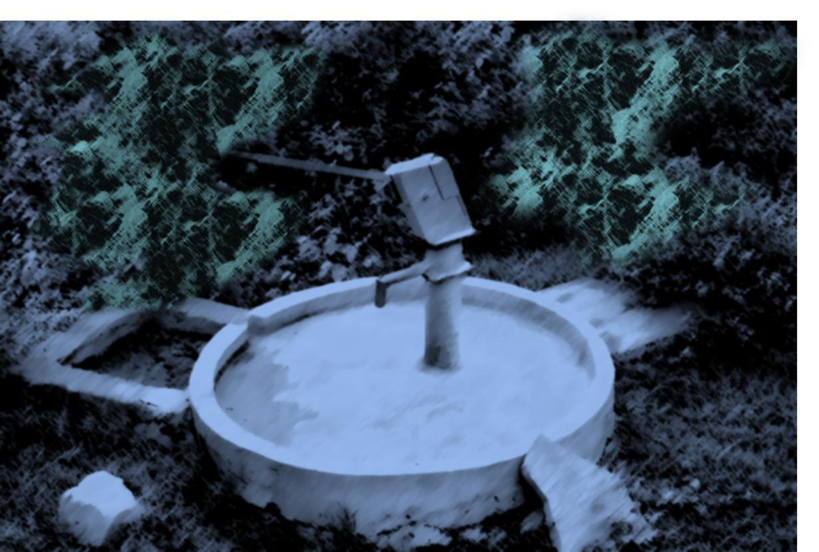

FACILITATOR’S GUIDE

**Water, sanitation and hygiene (WASH) governance training programme**

Developed by:

**IRC International Water and Sanitation Centre**P.O. Box 82327  
2508 EH The Hague, the Netherlands  
tel. +31 (0)70 3044000  
fax. +31 (0)70 3044044

website: [www.irc.nl](https://mail.irc.nl/owa/redir.aspx?C=67052d81a7ed49988b97cc0010e42622&URL=http%3a%2f%2fwww.irc.nl)





November 2011, Den Haag, The Netherlands

The entire WASH governance training programme can be found electronically at: <http://www.washgovernance.com/>

Acknowledgements

This WASH governance programme was prepared by IRC International Water and Sanitation Centre under the auspices of IRC’s local governance thematic programme and the Global Water for Sustainability (GLOWS) Programme of the Florida International University. Many of the materials in this programme are part of IRC’s WASH resources. Through the CAPWASH programme of GLOWS and the financial contribution from USAID these materials have been updated into the WASH governance training programme.

The programme was designed by Jean de la Harpe with inputs from Alana Potter, Deirdre Casella and Kerry Harris. The material draws upon the thematic content and contributions of various IRC staff working in the WASH sector.

[Description: Creative Commons License](http://creativecommons.org/licenses/by-sa/3.0/)

IRC WASH governance training programme by [IRC International Water and Sanitation Centre](http://www.washgovernance.com/) is licensed under the [Creative Commons Attribution-ShareAlike 3.0 Unported License](http://creativecommons.org/licenses/by-sa/3.0/). The programme is based on materials at [www.washgovernance.com/](http://www.washgovernance.com/). It should be referenced as follows: IRC, 2011.  *WASH governance training programme*, Den Haag, The Netherlands[www.washgovernance.com](http://www.washgovernance.com/)/

Contents

WASH Governance Training Programme 4

Purpose 4

Objectives of the training programme 4

Content areas 4

Overall approach of this WASH governance training programme 5

Component parts of the WASH governance programme 5

WASH Governance Training Programme Facilitator’s Guide 5

Purpose of the Facilitator’s Guide 5

Content of the Training Modules 7

Core modules 8

Cross cutting modules 9

How to design your WASH governance training programme 10

Step 1: Programme objective and content 10

Step 2: Select the most appropriate modules 10

Step 3: Tailor the session plans in each module 11

Preparation by participants 11

Materials needed for the training 12

Supporting resources for facilitators 12

Annexure 1: Participants preparation list 13

Annexure 2: Effective Facilitation Skills 15

Annexure 3: Options for exercises 17

Annexure 4: Planning Short Training Courses 20

Annexure 5: Example of a Training Course Evaluation Form 29

Annexure 6: Useful Resources and Websites 32

# WASH Governance Training Programme

Governance is about improving peoples livelihoods, alleviating poverty and increasing the chances of sustainable development. One of the biggest challenges in the water and sanitation sector in developing countries is the significant gap between policymaking and implementation. There is no blueprint for good governance but there are certain elements that need to be addressed towards improving governance. This training programme is about improving WASH governance with a focus on water and sanitation sector policy, institutions and systems that are better able to respond to sector challenges and ensure good governance and sustainable services.

## Purpose

The purpose of this WASH Governance Training Programme is to equip water and sanitation sector practitioners (trainers, capacity builders, NGOs, facilitators) to develop training programmes on water and sanitation governance and how to advocate good governance and best practices. It has been developed to provide a resource to strengthen governance and sustainability in the WASH sector. The approach is based on the recognition that ‘concepts’ are not sufficient to translate theories into practice and therefore the programme includes practical approaches to promote good governance and sustainable services.

The programme also aims to develop WASH institutional capacity through increased knowledge, understanding and action in terms of strengthening and improving WASH policy, planning, financing, institutional arrangements, and regulation with a focus on the local level.

## Objectives of the training programme

The objectives of the WASH governance training programme are:

* To provide an overall grounding in the area of WASH governance, what it means, the different components of WASH governance and its relevance to poverty reduction and sustainable services
* To provide tools and methodologies to promote good WASH governance within different contexts

# Content areas

The content of the programme includes a set of topics relevant to WASH governance and sustainable services provision. The content is designed to enable capacity builders, facilitators and trainers to meaningfully support the WASH sector in African countries. The emphasis of the content is on supporting local government to fulfil its WASH governance role particularly in terms of:

* Contextualising WASH services including institutional roles and responsibilities
* Contextualising WASH challenges within a locality (district / municipal area)
* Understanding what is meant by WASH governance
* The policy framework for WASH services
* Planning WASH services at the local government level (district/ municipal)
* Financing WASH services
* Developing WASH infrastructure through the WASH project cycle
* Selecting the most appropriate water services provider institutional arrangements
* Regulation and monitoring
* Factors to ensure sustainability, including transparency and accountability, appropriate technology, dealing with HIV/AIDS, equity and gender mainstreaming, advocacy and communication, capacity building and sector knowledge sharing.

## Overall approach of this WASH governance training programme

There are many ways to provide training and support to WASH governance. There are also many different definitions and explanations of what WASH governance is. There is no right or wrong way to deal with a subject of this nature. This training programme uses a particular approach. The approach is described in the background paper entitled: “*WASH local governance for improved services”* (de la Harpe, 2010) It is important to read this paper to understand the approach and logic of the programme and its modules.

# Component parts of the WASH governance programme

The WASH governance training programme comprises a set of components for capacity builders and trainers to facilitate processes towards improving WASH governance and the sustainability of water and sanitation services.

The components include the following:

1. This Facilitator’s Guide
2. A set of training modules including presentations, briefing notes, handouts and supporting resources
3. A WASH Wall Chart package with a set of interactive labels (which is part of Module 1)

# WASH Governance Training Programme Facilitator’s Guide

## Purpose of the Facilitator’s Guide

The purpose of this Facilitator’s Guide is to provide a stand-alone guide to the WASH Governance Training Programme including:

* An overview of the entire programme
* Information on the content of the training programme
* Guidance on how to use the training materials

The Facilitator’s guide is supported by a set of Modules.

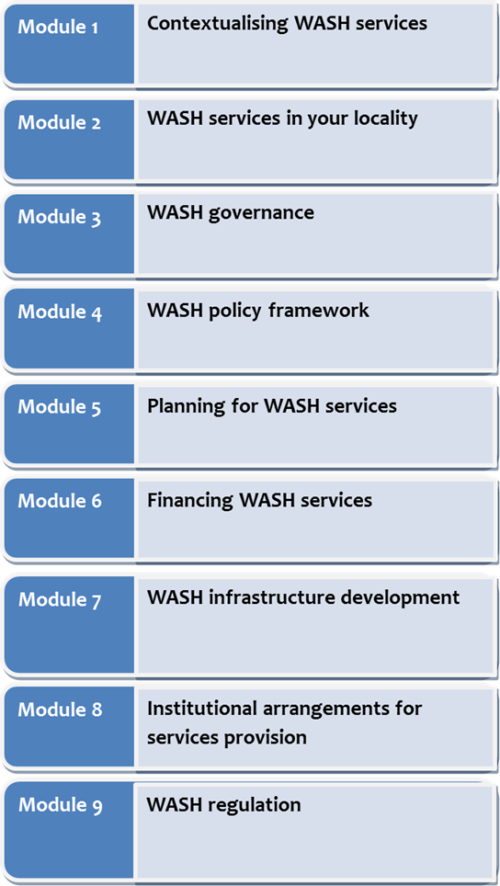

FACILITATOR’S GUIDE

Water, sanitation and hygiene (WASH) governance training programme

Each Module deals with a particular topic and includes a session plan and a step by step training plan.

The modules also include supporting briefing notes, presentations and hand-outs. The Modules provide both the content and suggested learning processes to facilitate learning in WASH governance issues.

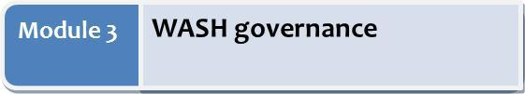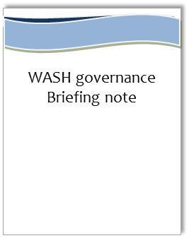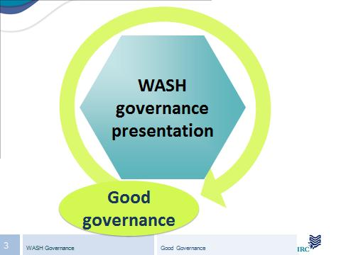

**Facilitator’s Note including:**

* **Introduction to the topic**
* **Purpose of the module**
* **Learning objectives**
* **Module outline**
* **Session plan**

# Content of the Training Modules

This training programme comprises 16 modules.

* Nine modules form part of a **core** WASH governance training programme, with Modules One to Three serving as introductory modules to the entire programme. In other words, these modules should be included in every tailor made programme.
* The additional eight modules address **cross-cutting** issues such as advocacy and communication, accountability and transparency, sector learning and sharing, appropriate technology, gender mainstreaming and HIV and AIDs in the WASH sector.

## Core modules

**Module 1**

**Contextualising WASH services**

* The water and sanitation ‘business’
* Institutional roles and responsibilities

**Module 2**

**WASH services in your locality**

* What is the status of WASH services in your locality?
* What are the challenges?

**Module 3**

**WASH governance**

* Overview of WASH governance
* Components of WASH governance

**Module 4**

**WASH policy framework**

* Key components of a policy framework for WASH services
* Policy issues

**Module 8**

**Institutional arrangements for services provision**

* Key stakeholders at local level
* Institutional options for WASH services provision

**Module 6**

**Financing WASH services**

* Importance of financing and cost recovery
* Factors for sustainable financing

**Module 5**

**Planning for WASH services**

* Strategic planning for WASH services
* Components of a water and sanitation development plan

**Module 7**

**WASH infrastructure development**

* Phases in the project cycle
* Ensuring sustainable services provision beyond the project cycle

**Module 9**

**WASH regulation**

* National and local level regulation
* Why it is important and what gets regulated

## Cross cutting modules

The following additional modules address cross-cutting issues to ensure and strengthen good governance across all WASH components. The training programme is still under development. This version of the WASH training programme includes modules 11, 15 and 17 of the cross cutting topics.

**Module 10**

**Capacity support**

* Importance of capacity needs assessment
* Capacity building approaches
* Importance of institutional indicators

**Module 11**

**Advocacy and communication**

* Importance of advocacy and communication for good governance and sustainable WASH services

**Module 13**

**Sector learning and sharing**

* Importance of sector learning and sharing
* Approaches to strengthening sector knowledge management

**Module 12**

**Accountability and transparency**

* Importance of accountability and transparency for good governance and sustainable WASH services
* How to improve WASH accountability and transparency

**Module 15**

**Mainstreaming gender and equity**

* Importance of mainstreaming gender and equity for good governance
* Factors that contribute to mainstreaming gender and equity

**Module 14**

**Appropriate technology**

* Why appropriate technology is important to sustainability
* Participatory technology selection

**Module 16**

**HIV and AIDS in the WASH sector**

* Importance of addressing HIV and AIDs challenges in the WASH sector
* Issues to consider

**Module 17**

**Monitoring and evaluation**

* Importance of M&E for WASH governance and sustainability
* Current trends and innovation
* Strengthening WASH M&E

# How to design your WASH governance training programme

The WASH governance training programme is a generic set of modules. These modules can be utilised to design a tailor made training programme.

**Preparation time:** Sufficient time should be allowed to prepare a tailor made training programme. As a ball-park provision should be made for approximately 2 days preparation time per one day of training. This is assuming that the existing modules will be used but that they will be contextualised and adapted to the needs of the particular target group.

## Step 1: Programme objective and content

The first step is to design the overall objectives and content of the training programme. Based on the objectives of the training, the appropriate modules can be selected according to the content areas that need to be covered.

In designing the programme objectives, it is a good idea to identify what the learners / participants need to know and understand at the end of the programme.

## Step 2: Select the most appropriate modules

Once the programme objectives and content areas have been identified, the appropriate modules can be selected.

If an overall WASH **governance** training programme is being designed, it is recommended that the first three modules are included as these modules ‘set the scene’ for the entire programme and the other modules build upon these modules.

**Module 1**

**Contextualising WASH services**

**Module 2**

**WASH services in your locality**

**Module 3**

**WASH governance**

Although there are strong linkages between the remaining 6 core modules, they are also designed as stand-alone modules so that the different modules can be put together into a tailor made training programme depending upon the specific needs of the learners.

If a one or two day training is required on a specific focus area, for example gender, transparency and accountability, etc., then the relevant modules can be used ‘outside’ of the entire WASH governance training.

For more information about the content of each module, refer to the first page of the facilitator’s notes for each module. This provides a description of what the module is about and the suggested learning objectives.

## Step 3: Tailor the session plans in each module

The modules are ‘generic’ in the sense that they are not designed for any particular country context. Trainers need to adapt and use the modules as appropriate for their target audience and country context. For example the session plans include a suggested time period to complete each session. However the time needed to run a session may be longer or shorter depending upon the number of participants, the level/s of understanding and the learning needs of the participants. Those who are designing the training therefore need to work with the modules to ensure that each session is ‘tailor made’ as appropriate.

The Facilitator Note for each module includes the following:

* Introduction to the topic
* Purpose of the module
* Learning objectives
* Module outline
* Session plan
* Preparation required by participants
* List of resources for the facilitator, such as supporting presentations, hand-outs etc.

Use the Facilitator’s Notes to tailor each module for example: the learning objectives, the module outline (which sessions to include or not include), and the detailed session plan (which is the steps per session). It might also be necessary to make some amendments to the presentations.

The resources for each module can be found in the Module folders on the WASH governance training programme CD, or at http: <http://www.washgovernance.com/>

# Preparation by participants

Since this training programme is designed to be as practical and useful as possible to participants’ current WASH contexts and challenges, they need to make some preparations for the training programme. This particularly applies to **Module Two: WASH services in your locality**. Each module specifies the information that participants should bring where the information is available. A **“Participants preparation list”** is included as Annexure 1 of this Guide.

Participants do not need to find the actual answers for all the information outlined in the list. However it is important to find out whether such information is available or not and to have some knowledge on the topics listed for each module. When finding answers to the information required, participants should be encouraged to use the opportunity to discuss the issues with their sector colleagues.

**Training programme invitation**

It is important that the letter of invitation to participants provides information about the preparation required by participants prior to attending the programme. The invitation should therefore include the **“Participants preparation list”.**

The invitation should include the following information:

* Purpose of the training
* The overall programme (which outlines the modules to be covered)
* Number of days
* Venue
* Costs
* Preparation required by participants
* Any other information you wish to communicate with participants in advance

# Materials needed for the training

The facilitator / trainer will need basic equipment and stationery for each of the modules, including the following:

* Laptop computer
* Overhead projector
* Flip chart X 2 (one flip chart for the facilitator and one flip chart for participants to make posters and notes)
* A4 sheets of paper
* Coloured cards
* Permanent marker pens including a selection of different colours with at least one pen per participant
* Blue tag (sticky material to stick up cards)
* String
* Glue
* Crayons

You will also need a training room that has a large wall to hang the Wall Chart for the first module. The Wall Chart is approximate 1.5 x 2.5 meters big.

# Supporting resources for facilitators

Additional supporting resources are included in the Annexures to this Facilitator’s Guide, for example notes on effective facilitation, options for exercises, an example of a training programme evaluation form.

# Annexure 1: Participants preparation list

Please prepare for your WASH governance training programme by finding out the following information about your locality. Some of the information may not be easily available. Even if you are not able to access specific answers, it is still important to find out what information is available as this will also give you an indication of the different types of systems that are in place and the overall institutional capacity of the local government. The process of finding out the information will also provide you with the opportunity to gain greater knowledge about WASH services in your locality.

| Module | Information required | | |
| --- | --- | --- | --- |
| Module Two  WASH services in your locality | * The name of the local government entity (e.g. municipality, district, etc) * Population / number of households/ total number of communities * Approximate size of area and settlement types * Infrastructure challenges (water backlogs and sanitation backlogs) * Number of towns * Average household income * Economic activities in the area (for example agriculture, commercial, forestry, mining, manufacture) * Service levels * Available water resources * Institutional challenges * Financial challenges   Participants should broadly have knowledge of these issues (if the information is available) | | |
| Module 3  WASH Governance | Does your local government have the following in place? (Yes/No)   * WASH policy * WASH bylaws * A water and sanitation services development plan * Targets for meeting the water and sanitation MDGs * A WASH budget * A WASH monitoring and/or reporting system * Contracts / agreements / arrangements with water and sanitation service providers * Is your local government responsible for local infrastructure development? | Yes | No |
| Module 4  WASH policy | * Bring a copy of your country’s national policy for water and sanitation services. Some countries may have more than one policy dealing with water and sanitation. | | |
| Module 6  Financing WASH services | * What is the tariff for water in the urban areas, and in the rural areas in your locality? * Does your local government receive a transfer or grant from national government for WASH services? If so what for? * Do you receive any grants from donors directly? * % cost recovery * Does your local government use taxes to subsidise water and / or sanitation services? * % water and sanitation budget spent on O&M * What is the value of current projects being implemented in your locality? | | |
| Module 8  Institutional arrangements for service provision | * What types of water and sanitation service providers are operating in your locality? (For example, utility, a local government, a community based organisation (CBO), a private operator, etc.) * What are the functions of the different water service providers in your locality? * Which water service provider do you think is providing the best service? Why? | | |

# Annexure 2: Effective Facilitation Skills[1]

**Interpersonal facilitation skills**

***Clarifying***– Checking whether you have understood correctly and probing for more information. For example, “it sounds like you’re saying…?” Clarifying always has an implicit question mark (?) at the end of the sentence. Leading through asking questions rather than giving facts creates understanding and gives learners an opportunity to discover things for themselves. Questions are more useful if they open up participation and discussion. It is therefore best to ask open questions that stimulate participation rather than closed questions that close participation down. For example, closed questions ask for ‘yes’ or ‘no’ type answers, while open questions ask for further information - ” could you tell me more about…”.

***Consensus testing*** – Checking with the learners how much agreement has been reached or how near they are to a conclusion. For example, “I think we have reached agreement on this. How do others feel?”

***Encouraging*** – Being warm, friendly and responsive to learners and their contributions, showing regard for them by giving them an opportunity for recognition. Acknowledge and appreciate the inputs and contributions from all learners and really listen to what they are saying.

***Expressing group feelings*** – Sensing feelings, moods, and relationships in the group and sharing your perceptions with them. For example, “It looks like we all need a short break.”

***Gate keeping*** – Attempting to keep communication channels open; facilitating the participation of as many people as possible. For example, “Sipho has been trying to say something for quite a while. Let’s listen to him”. This skill is also referred to as ‘blocking’ and ‘opening’, where the facilitator gently blocks more dominant learners and opens the way for less talkative learners. This ensures that all learners are given an opportunity to contribute and learn and ask questions.

Gate keeping is also a useful skill for off-the-topic questions or points. Capture the point and refer it to an appropriate place or resource, or suggest that the participant discuss it with an appropriate person during a break. Gate keeping is a bit like being a referee.

***Giving information*** – Communicating facts, information or clarification. Giving information is most effective when there is a demand for it from the learners.

***Harmonising*** – Attempting to reconcile disagreements; reducing tension; getting people to explore differences constructively. For example “maybe it would be a good idea to talk one at a time and give everybody a chance to say what they think.”

***Opening up*** – Facilitators do not need to know all the answers to all the questions that may be raised – use your team of resource people and the learners to contribute their ideas and knowledge to the questions raised.

***Opinion seeking*** – Asking for suggestions or ideas. For example “Tebogo has suggested that we come back to this later, what do others think?”

***Relieving tension*** – By bringing the tension out into the open, putting a problem in a wider context, or using appropriate humour. This is also important for energising the group.

***Summarising*** – Pulling together related ideas; concluding a section; pulling together the important elements of a discussion.

***Use of language*** – Use simple, accessible language that is appropriate to the group of learners. If there is a need for translation, use it.

In summary, effective facilitation is about building good working relationships with and within groups of learners.

**Technical facilitation skills**

***Time management*** – It is the facilitator’s responsibility to ensure that the time available for each activity or session is used well and for the benefit of the whole group. This implies the need to gauge the learners’ needs and manage limits.

***Writing up/ capturing skills*** (e.g. using the flipchart or board, etc) – Facilitators are often best placed to do this as it shows the learners that their point has been heard, plus its a useful tool for managing discussion, keeping it on track and preventing repetition of the same point. If you want support, ask one of the team to note ideas on the flipchart.

***Giving clear instructions*** – Where there are instructions or specific questions for discussion, it may be useful to write these up for all to see. It is important that they are clear. Give thought to how you will break a large group into smaller groups before it comes to breakaway sessions, as this saves time and ensures clarity.

***Positioning the environment*** – Seating arrangements and positioning of equipment in the room is an important part of facilitating participation and ensuring that all the learners in the room can see audio visual projections, flipcharts, and so on.

***Preparing or using appropriate and effective materials –*** This is crucial for ensuring meaningful participation and for achieving the objectives of sessions.

# Annexure 3: Options for exercises

#### Introductory or ‘setting the scene’ exercises

Setting the scene is essential to creating a safe and facilitative learning environment in which learners’ feel comfortable to participate and learn from the course, and to take responsibility for their role as learners.

Regardless of the exercises used, it will be a good idea to explore the following questions in the introductory session:

* What are learners bringing to the workshop? This could include questions/ concerns/ experience/ skills/ expectations and so on.
* What are they missing out on by attending?
* What are their hopes and fears for the training?
* What kind of training environment do they want to create that will help them to participate freely and learn best? This gives the trainer some ground-rules for the workshop, which should be placed somewhere easily visible throughout the training. Examples of ground-rules include talking one at a time, keeping cellular phones off during sessions; respect everyone’s views, no undermining each other, punctuality, and so on.
* It may also be a good idea to introduce the 'parking lot' idea here, or a place for capturing issues, concerns or questions raised by learners that are important, but not directly relevant to the session or module being covered. It’s important that the trainer follows up on these ‘parking lot’ issues, expectations or questions from the learners.
* Overall purpose of and background to the training - how and why it came about and the broad objectives to be achieved by the end of the training.
* How the training is structured and logistics in terms of session times, days, meals, breaks, and so on.
* Presentation of the workshop or session objectives and agenda, which should be linked to the learners’ expectations

**Some examples of introductory activities**

* Learners introduce themselves one after the other by selecting an adjective that starts with the first letter of their name and describes something about them.
* Learners walk around to find an object from the environment that represents what they are bringing to the workshop. They then present the item while introducing themselves and tell the participant group:
  + What they are bringing to the workshop.
  + What they want out of the workshop.
  + What they are missing by being at the workshop.
* Learners are asked to stand up and to move into groups according to the following example instructions. After each grouping, ask the learners to introduce themselves to the person on their right and the person on their left:
  + Move all the men on the left and the women on the right
  + Ask the learners to group themselves according to the areas they come from
  + Ask the learners to group themselves according to the colour of their shirts or shoes

**Plenary exercises**

* Quick collective brainstorming on a particular question or issue. The trainer captures the main points made by learners during the brainstorm on a flipchart and then facilitates a discussion.
* Quick collective free association to an idea or concept, where the learners say what immediately comes to mind and the trainer writes these words or phrases on the flipchart and then facilitates a discussion or gives further input on the ideas or concepts.
* Learners write their ideas or opinions on half A4 cards, one idea per card, and put them on a wall, then discuss in plenary.
* The learners find a partner and discuss or practice or consider a particular idea, concept or case study.
* Learners work in buzz groups of 3’s or 4’s and then report their main ideas to the big group for further discussion based on these report backs.
* Remember also that people can learn by reflecting on their own experiences, distilling the main ideas and then generalizing and applying these ideas to the issue being discussed. This can also happen in small groups.
* On the whole, it’s better to use small groups of no more than eight learners for most exercises as this ensures that all learners have an opportunity to speak and share their ideas, opinions and experiences.

**Brainstorming**

Brainstorming means giving free reign to the imagination by drawing out as many ideas about a topic as possible in a given time. There are no rights or wrongs and no judgement is placed on any comments. Brainstorming allows individuals and groups to try to capture all possible ideas or perspectives on a given topic within a given (usually short) amount of time. The outputs are the ideas, thoughts, questions, etc. that are documented preferably visibly on a flipchart so that the learners can interact with them as food for further ideas.

**General rules**

* Do not judge or criticise any ideas.
* Let ideas flow – be imaginative.
* Free wheel – build on other people’s ideas.
* Go for quantity, not for quality.
* Clarify items. Expand on an idea without evaluating it.
* Record all ideas, no matter how trivial it might seem.
* As soon as all ideas have been listed, assess and evaluate them openly in a facilitated discussion with all brainstorm learners.

**Using PowerPoint presentations**

* It takes on average two to three minutes to explain each slide. Therefore, do not have more than 10–15 slides for a 45-minute presentation.
* Avoid large amounts of text on a slide and do not just read from the slide.
* Put short statements on the slide as headings and reminders to yourself about what to say and in what order.
* Avoid colours that are difficult to read, such as red and yellow.
* Most importantly, check the slides yourself from where the learners will be sitting to see whether they are readable.
* Use of images and illustrations often is clearer than use of text

**For more PowerPoint tips and tools visit:** [www.knowwiththeflow.org](http://www.knowwiththeflow.org)

# Annexure 4: Planning Short Training Courses

(CAPNET 2007)**[2]**

#### Introduction

Short courses are effective instruments for continuous professional and adult education.

Short courses distinguish themselves from long term courses and educational programmes not only by the length of the activity but also the format and type of training offered. Typically they are interactive, build on the learners experience and emphasise facilitation rather than teaching.

With increasing emphasis on continuing education trainers and educators find themselves required to organise and implement short courses while often they may lack experience in managing such activities. This guide provides a brief summary of the points to consider.

The organisation of short courses can be a lot of work and you need to get it right. The success of the course comes as much from the organisation as the content.

#### 1. Subject

The first step is to formulate an idea for a short course that is going to meet needs of the target group. This is obviously important if you wish to attract learners and should be related to a knowledge of capacity needs and previous discussions with potential partners and clients.

Once the subject matter is established you may ask yourself:

* has there been a short course delivered on this subject recently, or is any useful literature, handbook or training manual available;
* what is the best way to deliver the required training;
* who are the best available facilitators;
* who has a particular interest in the subject;
* what insights can be gained from learners;
* who will fund the training?

#### 2. Target groups

Target groupsneed to be identified based on the objective of the course and the result expected. They may vary from water management planners to local water authorities or water users associations. Another target group may consist of capacity builders who will take the subject further in their day-to-day training and education activities. The potential client group will also be determined by the likelihood and type of funding of the training course. It is therefore important to realise what the intention of the course is and what you expect learners to do with it. The “audience” is also the determining factor when deciding on the length and format of the training course. Are there particular institutions likely to be your target for the course and who may want to partner with you?

#### 3. Format

Be it a training-of trainers course or targeted to water professionals, the learners will always be adults and therefore the format needs to be adapted to the audience. To keep the learners’ attention, it is important to vary between lectures, presentations, working groups, role plays, field trips, etc. The rule of thumb that has had positive feedback from learners is that a module (clusters of sessions on a particular subjects) is split in 1/3 presentation, 1/3 discussion and 1/3 interaction.

It is obvious but often forgotten that the contents of the training needs to reflect the level and work practices of the learners.

#### 4. Programming

In programming the short course there are several issues to be considered. In terms of your target audience:

* what is the ideal length of the course in relation to the target group (e.g. managers generally have less time for continuous content-related education than professionals)?
* does the course set-up appeal to the target group and prepare them better for their tasks?

Programme the course in such a way that all sessions, exercises, field trips, working group assignments are relevant to the subject matter. It is generally considered appropriate to begin with introductory sessions into concepts and principles are planned at the beginning of the course, followed by more technical and interactive sessions. Sometimes we may see field trips planned that have no other purpose than an organised outing for the learners. This may not be useful and may even interrupt the flow of the course. If a field trip is organised, make sure that it has a relation with the course subject and contributes to the training of the learners. Often specific assignments related to the field trip may be appropriate.

It is essential that the content of the course programme has enough platforms and outlets for the learners to express themselves. Interactivity is very important and adult education methods need to be used. Good methods to challenge the learners and extract knowledge from them are discussion platforms, working group assignments, role plays, and other interactive formats. Enough time should be allocated to these types of sessions.

The course content needs to be developed thoroughly and with partners if you expect them to send learners. Plan to make course materials available immediately to learners. It is preferable if these are in the form of properly prepared training materials.

At all stages keep communication with potential sponsors/ partners to gain their commitment to the course and develop a brochure to promote the course through networks and partners.

#### 5. Partners and facilitators

It is imperative that partners are involved in the organisation of the course. Partners can bring in essential elements in the programme and provide facilitators for specific sessions.

Partner choice can be based on particular strengths of the partner in the subject area of the course. But it can also be a strategic choice when bringing in a partner could lead to more dedication and buy-in in your programme or organisation.

Different types of facilitation and facilitators can be brought in the course that you are organising. As mentioned in the previous section, adult education requires a large degree of interactivity in the sessions and specific facilitation skills are required (see *Facilitation and Presentation Techniques* in the Cap-Net Network Management Tools). A major advantage of organising a course for professionals is that you may rely to a large extent on the capacities of the learners. However it is important to have knowledgeable and experience facilitators in the subject matter of the course who know how to teach adult learners.

#### 6. Choose a host and venue

Ideally in a network it is a member who proposes to host a particular network training activity. The host institution should have credibility and experience in the subject area. Selecting a host institution that is specialised in the subject to be trained has clear advantages for programming and facilitation.

This host then gets the credit for the course along with the network and the other partners. It is also important that the responsibility is clearly allocated to this organisation. Spreading the responsibility for activities around members brings them benefits and reduces the workload of the network secretariat.

When facilities are not available in-house at the host institution, often external facilities (hotels, conference centres) are used. Both options have advantages and disadvantages:

|  |  |  |
| --- | --- | --- |
|  | Advantages | Disadvantages |
| Internal | Inexpensive  availability of equipment, labs, etc.  classroom set-up for lectures  exposure of the network member’s institution | location may not always be convenient  lodging and food facilities may not be adequate  IT facilities  Bureaucratic administrative procedures |
| External | reduction on room rates or meeting rooms  learners stay together  no transportation between hotel and venue required  audio-visual facilities may be more adequate  location may be more convenient | ownership of the course  interaction with faculties, professors  costs may be higher in case lodging could be provided by host  interference/noise of other events in the same location |

#### 7. Develop a brochure/catalogue/concept note, and invite learners

The course brochure (or catalogue, concept note, or pamphlet) developed from the programme and arrangements serves to invite learners to the course, either internally in the network(s) and partners or externally through other organisations. The minimum content of a brochure contains:

* Introduction
* Objective
* Target group
* Description of the content
* Methodology
* Organisation
* Contact details and registration fee (see next section) information
* What the learners will gain from the course and what is expected after the training
* Course programme
* Background materials references
* Learner / participant preparation (where applicable)

#### 8. Draft the budget

The course should be organised on the basis of cost recovery. This is the only basis of planning as even if you find a donor they need to see how costs and charges have been arrived at.

It is usually better to separate the management arrangements and costs of the course from the travel and per diem arrangements. As far as possible get others, such as sponsors, to deal with the per diems and travel and that reduces the work load on you.

How do you calculate a course fee to cover the management costs? This is a bit more complicated as this is where you have to get into detail (see box for example).

a) The course fee should include things such as:

* hiring venue,
* facilitators costs,

**A rough example for a 5 day course (US$)**

2 trainers 2 x 5 days @ $150/day = 1,500

Perdiem 2 trainers x 5 days x $150/day = 1,500

Travel, trainers 2 x $500 = 1,000

Venue 5days x $100                     = 500

Materials and general copying            = 500

Local travel                                        = 500

Lunch  5days x 15people x 12$           = 900

Refreshments 5days x 2 x 15people x $5   = 750

10 days preparation @ 150$              = 1500

                                     total = $8,650

For 15 learners this makes $575 per participant to cover costs. If you actually got 25 learners at this fee you would have a comfortable margin of surplus. The calculation assumes that participant travel and per diem is covered by the sponsor.

* teaching materials,
* field trip,
* local travel,
* preparation time of organisers,
* lunches and tea breaks.

 b) Most of these costs will be fixed regardless of the number of learners. Items such as lunch and refreshments will depend on the final number of learners. Make the budget based on a minimum of 15 or 20 learners. That way if you get too few learners you know you will lose money and may have to cancel the course. If you get more learners you will make a small profit which will help you plan the next course.

c) You may be able to avoid some of these costs or reduce them by negotiating with hotels or the host institution. An important factor is the source of the trainers/ facilitators, their number and fee. In the end a regional course fee should be about US$500 for a week - it could be less. If it is much more expensive then you run the risk of not being attractive for learners or sponsors.

#### 9. Some practical arrangements

There are some practical arrangements that you may want to consider when organising a short course:

* Disseminate the **course announcement** in time and to a wide audience.
* Keep a distribution list so that it is easier to send out the announcement next time
* **Solicit participation** through network members, partners or external parties. Make sure that the target group is well defined and that criteria are clear.

Once learners have been identified, assist in application for visa. Sometimes a block-application for all learners directly with the Ministry of Foreign Affairs is the most efficient way to do it;

Learners and facilitators need to know **where to go** when arriving at the airport. Just the name of the venue or hotel may not be enough and they may require more specific instructions what to do when they arrive. Better is to have them picked up but that may not always be an option;

Make sure that before and during the course there is **a functioning secretariat** where learners can go with practical questions. You may want to have a secretary present at lunch/coffee breaks. FAQs at workshop secretariats almost always concern flight confirmations, per diems, internet facilities, shopping, etc.;

Assure yourself that all necessary **tools and equipment** for the whole course are available before the course starts. Ask facilitators beforehand what they need and if they have special requirements. It often turns out annoying when these things have to be arranged when the course has already started. Frequently used tools and equipment are:

* Flip charts
* Coloured markers, coloured cards, tape, blue tag (sticky material) and additional pens
* Overhead projectors and sheets (although they are getting outdated)
* Laptop and projector for presentation;

Organise **transport** to and fro between lodging and venue, and possibly for a field trip. If you organise a field trip, make sure that it is relevant to the course and that learners do not spend half a day in a bus;

**Guidance to the facilitators** is essential for the success of the course. Check there is no overlap between facilitators. You may prepare a session outline, suggest resource materials, and guide on presentation and interaction. It is good to have all session outlines collected before the course and make them available to the learners;

Prepare for the **proceedings** to be available to the learners at the end of the course. The proceedings may consist of the programme, session outlines, presentations, and resource materials (articles, references). They are usually distributed on CD-ROM;

At the end of the course it is useful to ask the learners to compete a **course evaluation** form. An example of a course evaluation form is attached as Annexure Four.

Any client will require a **financial report** after the course but it is also useful for your own administration. It is good to be aware of that before and during the workshop and make sure all receipts are properly kept.

#### 10. Checklist

Below is a short training course checklist developed by IWSD, Harare, Zimbabwe.

|  |
| --- |
| **Course name:**  **Date:**  **Venue:**  **Partners:** |

|  | **Course checklist** | | |
| --- | --- | --- | --- |
|  | **Activity** | **Responsible Person/Institution** | **Done by (date)** |
| **1** | **Identification of learners** |  |  |
|  | Course outline developed and agreed with partners |  |  |
|  | Course flyer developed |  |  |
|  | Electronically distributed to partners and other interested parties. |  |  |
|  | Learners list finalised |  |  |
|  | Successful learners notified |  |  |
|  | VISA letters prepared for those who need them |  |  |
|  | Special preparatory requirements communicated to learners (anything to be prepared prior to coming) |  |  |
| **2** | **Development of Course Programme** |  |  |
|  | Draft programme ready |  |  |
|  | Distributed to partners for Comments |  |  |
|  | Programme finalised |  |  |
|  | Final Programme communicated to partners, learners and facilitators |  |  |
| **3** | **Development of course budget** |  |  |
|  | Draft budget prepared |  |  |
|  | Course fee set. |  |  |
| **4** | **Identification of Facilitators** |  |  |
|  | Facilitators identified |  |  |
|  | Facilitators notified + any special format for material development |  |  |
| **5** | **Preparation of course materials** |  |  |
|  | Materials ready and sent to organisers |  |  |
|  | Material assessed for appropriateness |  |  |
|  | Feedback to Facilitator |  |  |
| **6** | **Travel Arrangements (if managed by organiser)** |  |  |
|  | Itinerary ready and communicated to travellers |  |  |
|  | Arrangement for ticket collection/purchase communicated |  |  |
|  | Arrival and departure dates communicated |  |  |
| **7** | **Development of pre and post course evaluation forms** |  |  |
|  | Pre-evaluation forms developed |  |  |
|  | Send to successful applicants |  |  |
|  | Feedback from learners received |  |  |
|  | Post course evaluation forms developed |  |  |
| **8** | **Purchase of Course materials** |  |  |
|  | Files, name tags, flip charts, VIP cards Markers etc |  |  |
| **9** | **Preparation of Course Venue** |  |  |
|  | Course venue ready +equipment and other teaching aids |  |  |
| **10** | **Registration Form** |  |  |
|  | Form designed and ready |  |  |
| **11** | **Course Certificate** |  |  |
|  | Certificate designed and shared with partners |  |  |
|  | Design finalised |  |  |
| **12** | **Preparation of Training Report** |  |  |
|  | Training Report |  |  |
| **13** | **Training Pack** |  |  |
|  | Preparation of Training pack |  |  |

#### 11. Useful reading for preparing a training course

* Candelo Reina, Carmen, Gracia Ana Ortiz R., Barbara Unger. 2003. Organising and Running Workshops; a practical guide for trainers. WWF-Colombia.
* Friends of the Earth. 2004. How to organise events. <http://community.foe.co.uk/resource/how_tos/organise_events.pdf>
* James Madison University, Office of Sponsored Programs. 2005. Specialized Proposal Development Guides. <http://www.jmu.edu/sponsprog/writingtips.html>
* Generation Challenge Programme. n.d. Guidelines for organizing workshops for the Generation Challenge Program. CIMMYT, El Batán Texcoco, Mexico <http://www.generationcp.org/sccv10/sccv10_upload/WorkshopGuidelines.pdf>
* Mineralogical Society of America. 2005. Basic instructions on how to plan, organize, and execute a short course. Chantilly, US.

# Annexure 5: Example of a Training Course Evaluation Form

We invite you to complete this course-evaluation form to help us improve our training activities. Please be frank and open with your ratings and comments. Your opinion – whether positive or negative - is valuable to us and will be considered in the preparation of future activities.

The average time it would you take to complete this form is around 10-15 minutes.

1. **Relevance of the course to your current work or function.**

|  |  |  |  |  |
| --- | --- | --- | --- | --- |
| None | Low | Medium | High | Very high |
|  |  |  |  |  |

1. **Extent to which you have acquired information / content that is new to you.**

|  |  |  |  |  |
| --- | --- | --- | --- | --- |
| None | Low | Medium | High | Very high |
|  |  |  |  |  |

1. **Usefulness of the information / content that you have acquired for your work.**

|  |  |  |  |  |
| --- | --- | --- | --- | --- |
| None | Low | Medium | High | Very high |
|  |  |  |  |  |

1. **Did the course reach your expectations and objectives?**

|  |  |  |  |  |
| --- | --- | --- | --- | --- |
| No | Little | Just enough | More than enough | Completely |
|  |  |  |  |  |

1. **As a training of trainers course, did the course prepare you for you to lead a follow-up course in your region/organisation?**

|  |  |  |  |  |
| --- | --- | --- | --- | --- |
| No | Little | Just enough | More than enough | Completely |
|  |  |  |  |  |

**What type of content / methodological support would you need to lead a follow-up course in your region/organisation? (excluding organisation or financial issues).**

**................................................................................................................................................................................................................................................................................................................................................................................................................................................**

1. Considering the implementation of IWRM and conflict resolution and negotiation, the sessions were:

|  |  |
| --- | --- |
| Fully relevant |  |
| Most of them relevant |  |
| Only some were relevant |  |
| Not relevant |  |

1. **The presentation of the different sessions was:**

|  |  |
| --- | --- |
| Excellent |  |
| Very good |  |
| Good |  |
| Regular |  |
| Bad |  |

1. Participation possibilities during the course were:

|  |  |
| --- | --- |
| Excellent |  |
| Very good |  |
| Good |  |
| Regular |  |
| Bad |  |

1. **The length of the course in terms of hours per day was:**

|  |  |
| --- | --- |
| Excessive |  |
| Adequate |  |
| Insufficient |  |

1. **Content materials in support for the different sessions were:**

|  |  |
| --- | --- |
| Excellent |  |
| Very good |  |
| Good |  |
| Regular |  |
| Bad |  |

Comments: **..........................................................................................................................................................................................................................................................................................................**

**....................................................................................................................................................**

1. **The presentation of case studies and experiences enabled you to appreciate the applicability of the issues discussed:**

|  |  |
| --- | --- |
| Completely |  |
| Sufficiently but without covering all issues |  |
| Insufficiently |  |

1. Has the course changed your perception of how training of trainers should be conducted?

|  |  |  |  |
| --- | --- | --- | --- |
| Yes |  | No |  |

If yes, how?

........................................................................................................................................................................................................................................................................................................................ ....................................................................................................................................................................................................................................................................................................................................................................................................................................................................................

1. What particular elements are missing, or what elements should have been given more attention in the course?

............................................................................................................................................................ ............................................................................................................................................................ ....................................................................................................................................................................................................................................................................................................................................................................................................................................................................................

1. What did you find most useful in the course, and why?

........................................................................................................................................................................................................................................................................................................................ ....................................................................................................................................................................................................................................................................................................................................................................................................................................................................................

1. What did you find least useful, and why?

........................................................................................................................................................................................................................................................................................................................ ....................................................................................................................................................................................................................................................................................................................................................................................................................................................................................

Thank you for taking the time to fill out this survey. Your inputs will be considered to improve the quality and significance of future activities and they are highly appreciated.

# Annexure 6: Useful Resources and Websites

Anticorruption, The World Bank, go.worldbank.org/QYRWVXVH40

Anti Corruption Coalition Uganda (ACCU), [www.accu.or.ug](http://www.accu.or.ug)

Cap-Net UNDP, International Network for Capacity Building in IWRM, [www.cap-net.org](http://www.cap-net.org)

EU Water Initiative, [www.euwi.net](http://www.euwi.net)

Gender and Water Alliance, [www.genderandwater.org](http://www.genderandwater.org)

Global Water Partnership, [www.gwpforum.org](http://www.gwpforum.org)

Internet Center for Corruption Research, [www.icgg.org](http://www.icgg.org)

IRC International Water and Sanitation Centre, [www.irc.nl](http://www.irc.nl)

LA-WETnet, Latin America Water Education and Training Network, <http://la-wetnet.org/>

The Government Accountability Project, [www.whistleblower.org/template/index.cfm](http://www.whistleblower.org/template/index.cfm)

The Stockholm International Water Institute (SIWI), [www.siwi.org](http://www.siwi.org)

The Swedish Water House, [www.swedishwaterhouse.se/opencms/en/](http://www.swedishwaterhouse.se/opencms/en/)

Transparency International, [www.transparency.org](http://www.transparency.org)

UN Economic Commission for Latin America and the Caribbean (ECLAC), <http://www.cepal.cl/drni>

UNDP Water Governance Facility, [www.watergovernance.org](http://www.watergovernance.org)

UNESCO Centre for Water Law, Policy and Science, [www.dundee.ac.uk/water](http://www.dundee.ac.uk/water)

Water and Sanitation Program, [www.wsp.org](http://www.wsp.org)

Water Integrity Network, [www.waterintegritynetwork.net](http://www.waterintegritynetwork.net)

Waternet, [www.waternetonline.ihe.nl](http://www.waternetonline.ihe.nl)

World Bank Institute, Governance & Anti-Corruption, go.worldbank.org/KUDGZ5E6P0

World Bank, Water & Sanitation Programme, [www.wsp.org](http://www.wsp.org)

1. Potter, A (2008), Training Social Animators, Mvula Trust South Africa for Government of Mozambique.
2. <http://www.cap-net.org/databases/network-management-tools>.