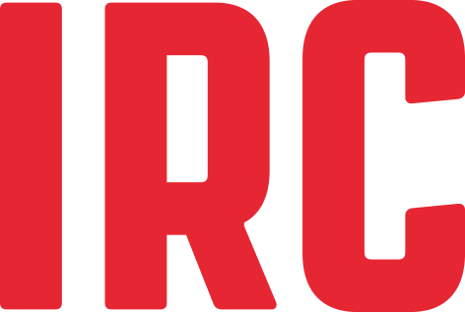 Ton Schouten Award 2022 - Terms and Conditions

About the candidates
Applications are open for young professionals (over the age of 18 and under 35), who:

1. are from and working in a low- or middle-income country,
2. are dedicated to storytelling within the WASH sector, and
3. have a portfolio of WASH related communication products (e.g., blog, a video, cartoon, poster, podcast).
Current employees of IRC, interns and associates or an immediate family member of any of the aforementioned, are not eligible to participate.

Technical specifications for communications materials
Communications content must not contain violence, profanity, sex or direct attacks on individuals or organisations. Any entries deemed offensive will be immediately disqualified. All content must be an original creation - no copyrighted images may be used. The participant must certify and warrant that the submitted material(s) does not violate the rights of a third party or any copyright. IRC is not responsible for intellectual property violations that might have resulted through the submissions of photos.

EU General Data Protection Regulation
The submitted content must adhere to the GDPR.

Selection process and notification of award winner
After the contest closes, qualifying nominees will be judged on adherence to the contest challenge. IRC’s selection committee to judge the entries. Any attempt by a participant to influence the result or subvert the award will lead to immediate disqualification. Nominees will be notified by email. If an entrant is unable to be contacted after reasonable attempts have been made to do so, IRC reserves the right to offer the prize to the next best entry.

General
IRC reserves the right to modify or cancel the contest or any of the arrangements, schedules, plans or other items directly or indirectly related to the contest, at any time and for any reason if deems necessary. The personal information provided to IRC by the participants shall only be used for the purposes of this contest. All participants are entitled to access, cancel, oppose and rectify the details about the personal data (such as names, addresses, etc.) contained in the file by sending their request by email to tonschoutenaward@ircwash.org

Participation in the awards in no manner constitutes an endorsement or support by IRC of the candidates’ views or aims or of any products or services. Candidates shall not advertise or otherwise claim to have obtained any such endorsement or support. IRC name and logo are the property of IRC and should not be used in any manner whatsoever without the prior consent of IRC. IRC must approve in writing any statement, advertisement, press release or similar communication in any media, relating to candidates’ participation in the competition.

For more information contact us at tonschoutenaward@ircwash.org

