8 August 2018

Assessing the sanitation situation in a resettlement colony in Delhi
  - Using IRC's Faecal Waste Flow Calculator in India
Shiny Saha and Ruchika Shiva

Prepared by Shiny Saha and Ruchika Shiva on behalf of IRC. This report was edited by Tettje van Daalen and formatted by Marion Giese. For questions or clarifications, contact IRC: www.ircwash.org/contact-us.

This case study addresses if existence of toilets can be considered improved sanitation. Using IRC’s Faecal Waste Flow Calculator to conduct a rapid assessment of the sanitation situation in a settlement in Delhi, the authors explain that while household toilets are necessary, they alone are not sufficient for improved sanitation.

IRC
Bezuidenhoutseweg 2
2594 AV The Hague
The Netherlands

T: +31 70 3044000
www.ircwash.org
Contents
Figures 3
Abbreviations 3
Introduction 4
The case study 5
Sustainable Development Goals and the case study 8

Figures
Figure 1 Flow diagram generated by the Faecal Waste Flow Calculator 8
Figure 2 SDG 6.2 service level definition 9

Abbreviations

CTC | Community Toilet Complex
DUSIB | Delhi Urban Shelter Improvement Board
IHHL | Intra-Household Latrine
JJ | Jhuggi Jhopdi (slum)
NGO | Non-Governmental Organisation
SBM | Swachh Bharat Mission
SDG | Sustainable Development Goal

Introduction
Safe water and sanitation are fundamental to the health of every person in the country, yet many do not have access to these basic necessities. An important step towards resolving this challenge is to unbundle safe sanitation and understand the issue better. Does the mere existence of household toilets imply safe sanitation? Do improved facilities imply safe sanitation facilities? To help answer such questions, we recently conducted an assessment using the proprietary rapid assessment tool in a Jhuggi Jhopdi (JJ) resettlement colony in Delhi.

Objective of the study
The objective of the study was to assess the existing sanitation situation in the JJ resettlement colony and examine if having access to toilets can be considered as safely managed sanitation. The task was to highlight where efforts have stagnated or excelled in achieving goals of providing sustainable and safe sanitation. The rapid assessment tool was used to understand the existing sanitation situation and to gather systematic information on access and practices along the entire sanitation service chain for evaluation.

Understanding JJ resettlement colony
A JJ resettlement colony is one in which residents of JJ clusters (i.e. squatter settlements that have not been notified as slums under the Slum Areas (Improvement and Clearance Act, 1956, thus, considered illegal structures) are relocated after an eviction drive. JJ clusters are often viewed as encroachments on ‘public land’ and thus, the residents therein are subject to frequent eviction drives. Delhi has witnessed three waves of relocation since independence – in the 1960s, 1970s and in the 2000s. There are at present 55 JJ resettlement colonies in Delhi with an estimated population of more than 1.776 million.
JJ clusters or squatter settlements are typically considered ‘unfit and unhygienic’ and the resident communities need to be rehabilitated to establish 'humane living conditions' with access to basic services. The Delhi administration’s approach towards rehabilitation of JJ cluster residents has seen some changes over the years. The initial approach favoured relocation to resettlement colonies, which are usually located in the outskirts of the city. In the 1990s a three pronged strategy for rehabilitation was adopted - relocation, in-situ upgradation and environmental upgradation to basic minimum standards. However, relocation remained the preferred form of rehabilitation. The latest policy – the Delhi Slum & JJ Rehabilitation and Relocation Policy, 2015 – prescribes in-situ rehabilitation, within a 5 km radius of the JJ cluster or squatter settlement. It is only in the rare case, where in-situ rehabilitation is not possible, that it prescribes relocation.
It is only recently that the Delhi administration has started to prepare for in-situ rehabilitation. Evictions have otherwise, been followed by relocation to resettlement colonies. JJ resettlement colonies, unlike JJ clusters, are expected to have some degree of planning, as they have been included within the development area of successive master plans. JJ resettlement colonies are arguably the only other housing category in the city that satisfies the conditions of planned colonies. However, evicted squatter residents are resettled only on providing proof of residency in a JJ cluster before a cut-off year. Families that meet the eligibility criterion are allocated plots, the size specifications of which have varied over the three master plans - from 80 square metres in 1962, to 25, 18 square metres in 2001 and now back to 25 square metres in the latest 2021 Master Plan for Delhi. Those that are allocated space are given a non-transferable license that may have to be renewed after a certain period of time instead of an official title deed to the plot.

The case study
The JJ resettlement colony chosen for the study is one of the newer colonies that have emerged as a result of the evictions undertaken for the 2010 Commonwealth Games in Delhi. Established in 2006, the colony is located in North Delhi, where people have been relocated from 17 JJ clusters from all across the city, including a few from prime and core city areas such as Lodhi Road, Khan Market, Nizamuddin, Pragati Maidan, Jawaharlal Nehru Stadium and more. Spread over 250 acres, the sizes of the plots allocated were determined on the basis of two cut-off years. The first set, were those that could satisfy proof of residency prior to 1990 were allocated plots of 18 square meters in size and, those with proof of residency before 1998 were allocated plots of 12.5 square meters in size. The residents were allocated the plots on a ten-year lease, which expired in 2017 and is yet to be renewed. The number of occupied households in the colony is estimated to be 3,598, with a population of 17,846.

Background
The initial settlers of the colony first arrived to find bare plots, without access to basic services (electricity, roads, water, sanitation, or transport connection). Over time, and with the continued effort of a few NGOs, certain basic services have been put in place. The colony has been connected to the power grid since 2007. Although it is not linked to a piped water network, the colony gets drinking water from water tankers and water ATMs provided by the Delhi Jal Board. The colony lies on the Delhi Transport Corporation bus route and is soon to be connected to the metro rail network. The Delhi Urban Shelter Improvement Board (DUSIB), the organisation in charge of governance of the colony since 2010 (taking over the responsibilities from the Slum and JJ Department that had originally managed the allotment of plots in 2006 and 2007) has built roads, storm water drains and community toilet complexes (CTCs) in the settlement. These services have now been handed over to the concerned municipal authority, which is also responsible for solid waste management in the colony.

Sanitation appraisal of the JJ resettlement colony
In terms of the current sanitation scenario in the colony, there are community toilet complexes (CTCs) which are shared toilet facilities that are constructed for use by the community. The CTCs are owned and maintained by the municipality with certain community members entrusted with the responsibility to ensure that the facilities are kept clean and are not vandalized. There are CTCs in each occupied block of the colony but the inconvenience of waiting in queues, limited hours of operation and poor maintenance of the CTCs, together with the larger socio-political environment created by the Swachh Bharat Mission (SBM), has led to an increase in the construction of intra-household latrines (IHHL). While SBM has led to the creation of an environment that favours demand for household toilet construction, none of the residents in this settlement have received the SBM toilet construction incentive (government subsidy).
According to our assessment, 2055 (57%) of the 3598 households in the settlement have individual toilets. These households have built their own toilets (in some cases with the support of NGOs such as Mahila Housing Trust). In this process of building individual household toilets, there has been no attempt by local authorities to monitor the type of structures put in place (containment/onsite treatment). In the absence of a sewer network in the resettlement colony, the IHHLs are connected to underground holding tanks, which are emptied by a private contractor (monthly or bi-monthly at a cost), or they empty into storm water drains or open cesspools. In one of the blocks, the households are connected to a decentralized small-bore sewerage system, which is linked to a communal septic tank put in place by an NGO.
While conducting the study, it was found that most households with their own toilets only used IHHLs. The usage of the CTCs was found to have reduced, especially in the blocks where individual toilets had been constructed. However, some households with IHHLs were found to continue the use of CTCs, either due to a big family size and/or out of fear of the onsite holding tanks getting filled up faster. Since January 2018, the use of CTCs had been made free by the government; however, it was found that a fee of Re. 1 or Rs. 2 per use (which is considered expensive for many of the households in the resettlement area) continued to be charged. As a consequence, some open defecation was also found to be practiced by children and/or the poorest, usually, the tenants, who did not have access to IHHLs.
Emptying and transportation of faecal waste was carried out by one private service provider. The private service provider used a tractor customized to fit a vacuum tanker - typically a 'jugaad' truck - to empty the pits and holding tanks. Depending on the access and size of the tank, the emptying charge ranged anywhere between Rs. 400 to Rs. 800. The process of emptying, as observed, did involve only the minimum amount of human contact (e.g. when emptying hoses need to be disconnected and or cleaned with water). For some households, the emptying services were not required as they were either connected to a decentralized sewer network or their onsite holding tanks were directly connected to the storm water drains. CTC septic tanks were emptied by the concerned municipal authority, albeit infrequently. Some CTC septic tanks too were found discharging into open drains.

Sanitation rapid assessment
To understand the sanitation situation in the JJ resettlement colony, IRC’s Faecal Waste Calculator was used to conduct a rapid assessment of the sanitation situation in the colony.

Methodology
IRC’s Faecal Waste Calculator tool is a fast and simple-to-use tool that offers an easily understood representation of the volumes of faecal waste safely dealt with at each stage of the sanitation service chain, as well as, provides a scorecard analysis of governance related and other enabling factors. The tool reveals and quantifies some of the serious problems with regard to management of faecal waste. Thus, it allows stakeholders to evaluate the current sanitation situation, identify the challenges most in need of improvement, and identify possible solutions, map out scenarios and make the most effective use of available funds.
The volumes of faecal waste lost between each of the six links in the sanitation chain - capture, containment, emptying, transport, treatment, and safe use or disposal - is the main focus of the tool. Primary data from households as well as out-of-home facilities is used. Additional data, collected from local stakeholders and others involved in sanitation service provision, is required to enable the calculations. The tool calculates the volumes of faecal waste safely passed on and lost at each element of the sanitation chain. The tool automatically creates a number of diagrams which help to illustrate the volumes safely passed on and volumes lost at each of the six links, and thus showing the link that poses the greatest threat to the inhabitants.
Further, secondary data is used to generate a scorecard analysis of other more qualitative data on governance and other enabling factors.

Learning outcomes
The sanitation service chain shown in Figure 1 comprises of six elements: capture, containment, emptying, transport, treatment and safe reuse or disposal.
In the study area, with the existence and usage of a high number of IHHLs (and some use of CTCs), 99.6% of the total faecal waste (human excreta, urine, and black water used for anal cleansing and flushing) generated in the area was estimated to be captured in onsite pits or holding tanks. However, due to leakage or direct connection of the tanks to open storm water drains, the amount of faecal waste that was contained safely reduced to 67.3% of the total waste generated.
In terms of emptying, 27.6% of the faecal waste was calculated to be safely emptied by the private service provider or safely passed on through the decentralised sewer network. At this stage, some minor spillage at the time of removing and cleaning the suction pipes was observed. Also, taking into consideration the frequency of trips made by the private service provider to empty the tanks and the average size of the latter, some amount of faecal waste was calculated to not being emptied from the tanks.
In terms of transportation, only 15.4% of the faecal waste was calculated to be safely transported. This comprised only of the waste transported through the decentralized sewer network to the communal septic tank (and the waste transported by the urban local body from the CTC septic tanks). The household waste was not calculated as safely transported as the private service provider was observed to illegally dump the waste into an open canal north of the resettlement colony.

Figure 1 Flow diagram generated by the Faecal Waste Flow Calculator
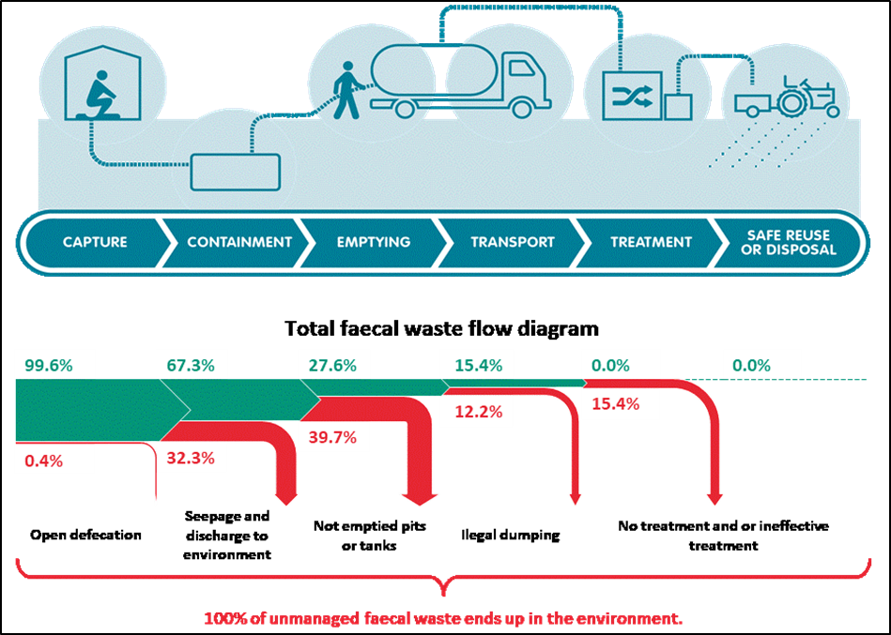
Further along the chain, 0% of the total faecal waste was estimated to be safely treated or disposed. This was also confirmed in the case of the few households connected to the communal septic tank through the decentralized sewer network. The communal septic tank was designed for emptying once in every two years. However, since its construction in 2007, the solid matter had not been removed at all due to the unavailability of appropriate desludging equipment. As a consequence, the capacity of the septic tank had reduced and thus reduced the retention time required for partial treatment in order to meet the environmental standards. The effluents contained in the communal septic tank were emptied at least once a week and disposed in the same open canal north of the resettlement colony.
The rapid assessment presents a relatively positive image in the resettlement colony at the beginning of the sanitation service chain. This positive image begins to deteriorate from the second element onwards, culminating at 100% of the total volume of faecal waste discharged untreated in the environment. Due to the increased use of intra-household toilets (that separate excreta from human contact) one can conclude that at the household level there is use of improved facilities. However, as the above figure illustrates, the use of improved facilities does not necessarily imply safe sanitation.

Sustainable Development Goals in the context of the case study
Sustainable Development Goal (SDG) 6 aims to ‘Ensure availability and sustainable management of water and sanitation for all’ and it comprises of six technical targets that relate to drinking water, sanitation & hygiene, wastewater management, water efficiency, integrated water resource management and protection of aquatic ecosystems. The 2030 target with respect to sanitation (SDG 6.2) is to ‘achieve access to adequate and equitable sanitation and hygiene for all and end open defecation, paying special attention to the needs of women and girls and those in vulnerable situations.’ The corresponding indicator for measuring the target is ‘proportion of population using safely managed sanitation services, including a hand-washing facility with soap and water’.
According to the monitoring ladder for SDG 6.2 (Figure 2), use of improved sanitation facilities is critical to a basic or safely managed sanitation situation.
Figure 2 SDG 6.2 service level definitions
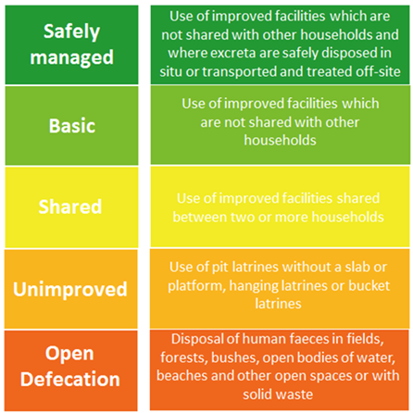
Improved sanitation facilities are inclusive of those that are designed to hygienically separate excreta from human contact. If these improved sanitation facilities are used by the residents of only one family, and thus not shared with other households, then these facilities will be called basic. A safely managed sanitation service requires individual households to have access to an improved sanitation facility that is not shared with other households, and the excreta produced should either be:
- treated and disposed of in situ
- stored temporarily to be emptied and transported for treatment off-site, or
- transported through a sewer with wastewater and then treated off-site.

As mentioned above, the increased use of intra-household toilets that separate excreta from human contact, imply that there is access to improved sanitation facilities in the settlement. However, with the lack of safe treatment and safe disposal of faecal waste, the individual household toilets (IHHL) found in the settlement are best described as ‘basic’.

Recommendations
The research and the subsequent data that emerged from this study enhances the understanding and the linkages between provision of toilets and waste management in the safely managed sanitation context. To move up the sanitation service levels to the stage of ‘safely managed sanitation’ certain steps need to be considered, such as:
- To ensure safe capture - households without their own toilet need to be identified and supported to obtain basic sanitation services on a priority basis.
- To ensure safe containment - some degree of regular service level monitoring by the relevant authorities is required to make sure that the onsite holding/septic tanks and the CTCs do not leak or do not discharge into the storm water drains and/or the open environment, and are regularly emptied. It would help if official minimum standards for toilet construction (building codes) were to be made available and adhered to by all.
- To ensure safe emptying and transportation - registration and regulation of private service providers (private desludgers) in line with the new Faecal Sludge and Septage Management Policy developed by the Ministry of Housing and Urban Affairs is required. This should include monitoring of transportation and dumping of faecal waste. Designated safe dumping points (e.g. faecal sludge treatment plants) need to be developed at reasonable distances.

Conclusion
Sanitation improvement is not as straightforward, as it may seem. In the context of the JJ resettlement clusters, provision of toilets is the first step towards improvement of the sanitation situation. Without proper treatment and disposal options, however, the threat to human health remains. To ensure safely managed sanitation it is vital to not only provide facilities that are easily accessible to all, but also ensure that the operations are sustainable along the entire sanitation service chain, with safe containment, emptying, transportation, treatment and disposal. Communication on safe sanitation and hygiene practice is required throughout the chain.

Visiting address
Bezuidenhoutseweg 2
2594 AV The Hague
The Netherlands

Postal address
P.O. Box 82327
2508 EH The Hague
The Netherlands

T +31 70 3044000
info@ircwash.org
www.ircwash.org

Shahana Sheikh, Subhadra Banda, and Ben Mandelkern, ‘Planning the Slum: JJC Resettlement in Delhi and the Case of Savda Ghevra’. Centre for Policy Research, New Delhi (August 2014).
‘Categorisation of Settlement in Delhi’. Centre for Policy Research, New Delhi (May 2015).
‘Delhi Slum & JJ Rehabilitation and Relocation Policy 2015’. Available at http://delhishelterboard.in/main/wp-content/uploads/2016/04/Policy-Part-A-amended.pdf.
Delhi has had three master plans till date – Delhi Master Plan 1962, 2001 and 2021.
Gautam Bhan, ‘Planned Illegalities Housing and the ‘Failure’ of Planning in Delhi: 1947-2010’. Volume xlviiI No. 24 EPW (June 2013).
Ibid.
Delhi Urban Shelter Board: Actual Budget 2017-18 & Budget Estimates 2018-19; pp v, http://delhishelterboard.in/main/wp-content/uploads/2018/08/BUDGET-2018-19-1.pdf.
In the Indian parlance, jugaad means a hack or a creative solution that somehow accomplishes a task.
IRC WASH Toolkit: Faecal Waste Flow Calculator, https://www.ircwash.org/tools/faecal-waste-flow-calculator.
https://amrut.gov.in/writereaddata/FSSM_Policy_Report_23Feb.pdf.

