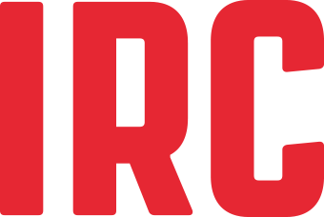

Photography consent form
I give consent to use of the photograph (s) in which I appear (copy attached or link to online version) to be used in in all print and digital media, including print publications, posters, brochures, websites and social media, by IRC and the photographer.
I may revoke my consent at any time by contacting IRC and the photographer (see contact details below). By revoking my consent, IRC and the photographer will refrain from using my photograph(s) in future print media publications and we will remove your photographs from our websites and, where possible, from our social media.
By signing this form I understand and agree with the above conditions.
Name
Date
Signature

For minors (17 or younger)
Name of parent
Date
Signature

Contact details
IRC
Photographer

