
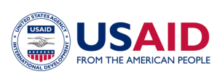

USAID West Africa Water Sanitation and Hygiene Program (USAID WA-WASH)

Annexes to the report on the WA-WASH Capacity Building forum
2012, July 16 – 18, Ouagadougou
Performance Period: August 15, 2011 – September 30, 2012

September 2012

Contents
Annex I Presentation Update on KM and CB regional organisations 2
Part 1: Update on KM | What has been done until today? 2
Part 2: Update on KM | What is expected from partners? 6
Part 3: CB regional institutions | What changed? 8
Part 4: Learning & Sharing platforms | Tour d’horizon desk research 10
Part 5: Learning & Sharing platforms | Guiding lights … 16
Annex II Capacity Building in Burkina Faso 17
Annex III Capacity Building plans in Burkina Faso 19
Annex IV Partner meeting linking to capacity building 21
Annex V: Agenda Capacity Building forum 23

Prepared by Jaap Pels, IRC, September 30, 2012

Annex I Presentation Update on KM and CB regional organisations
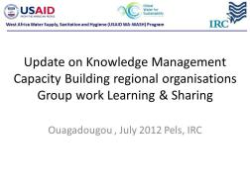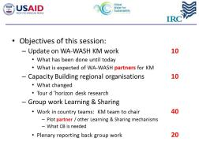

Part 1: Update on KM | What has been done until today?
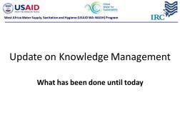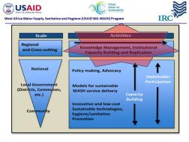
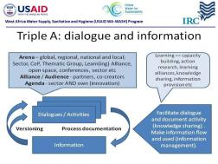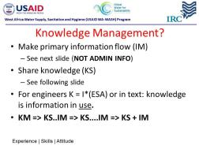
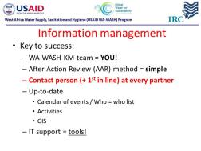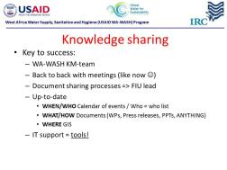
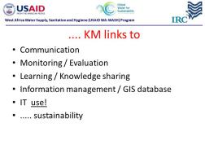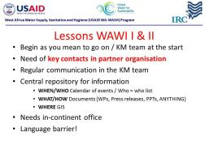
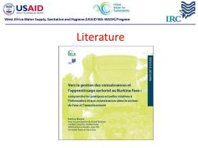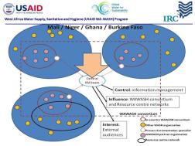
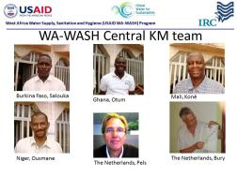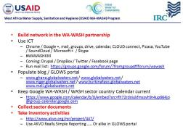
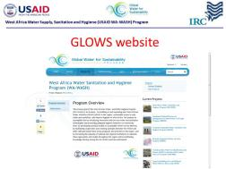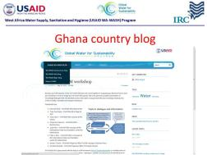
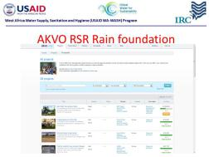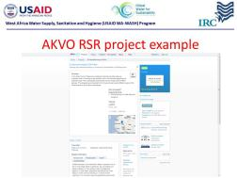
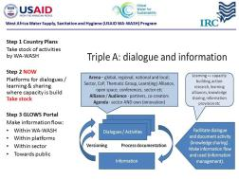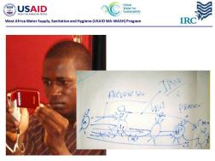
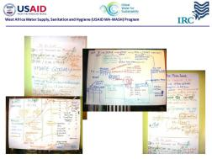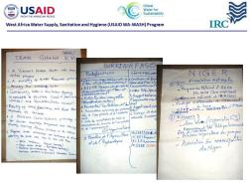

Part 2: Update on KM | What is expected from partners?
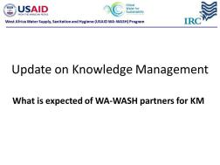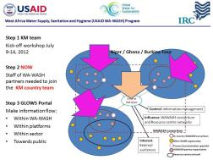
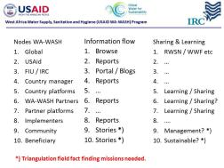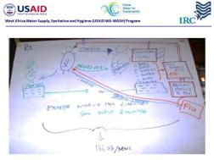
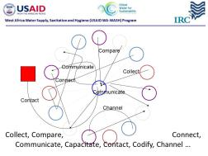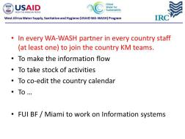
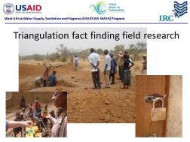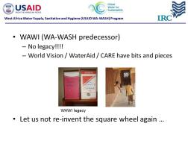
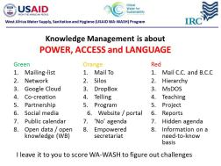

Part 3: CB regional institutions | What changed?
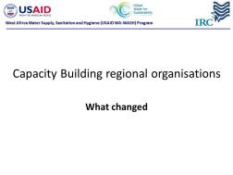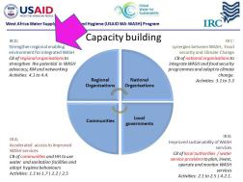
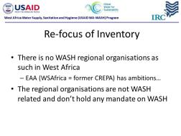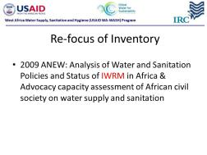
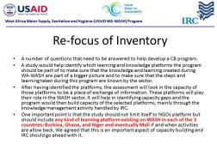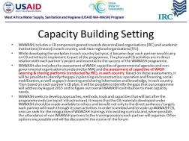
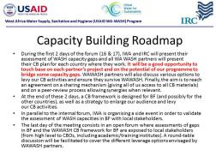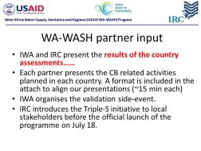

Part 4: Learning & Sharing platforms | Tour d’horizon desk research
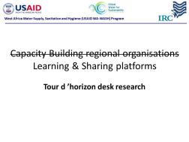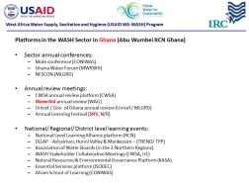
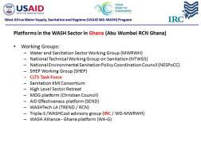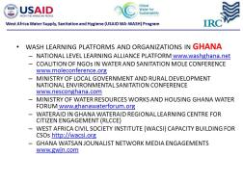
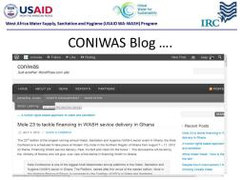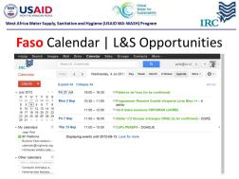
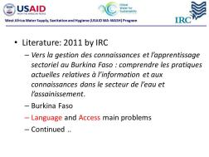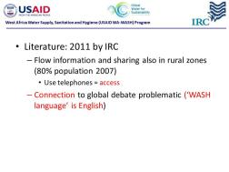
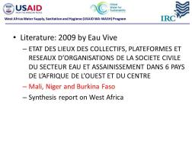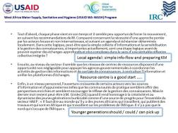
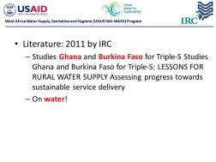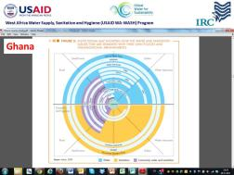

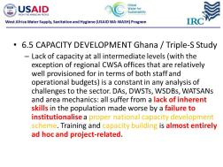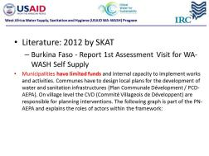
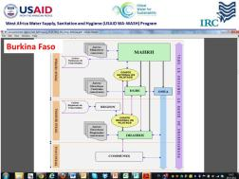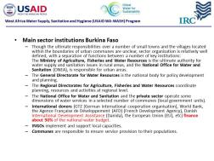
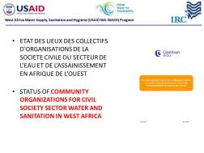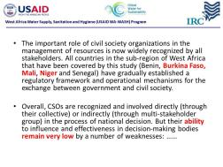

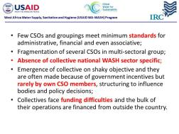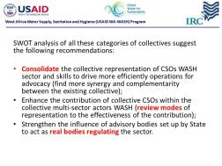
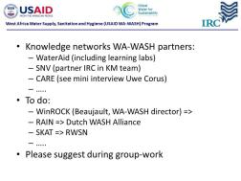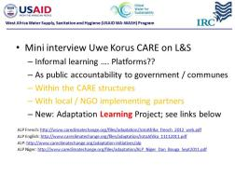
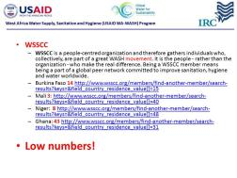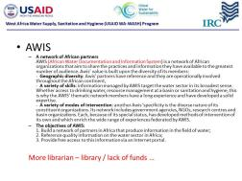

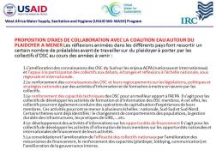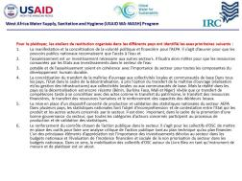
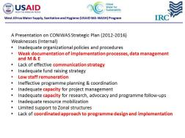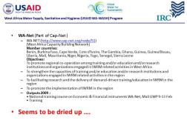
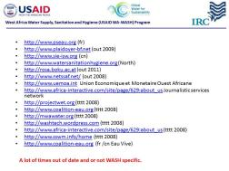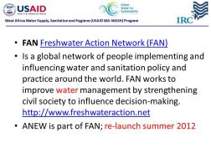

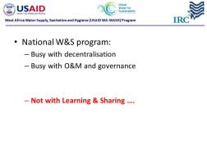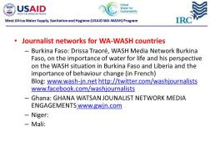
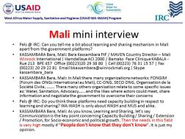

Part 5: Learning & Sharing platforms | Guiding lights …
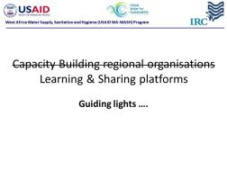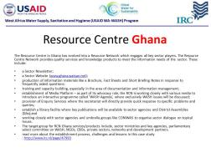
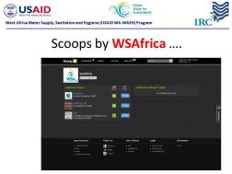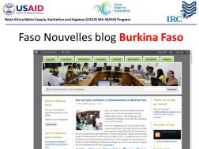
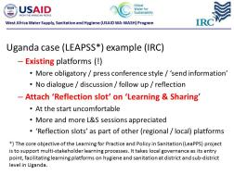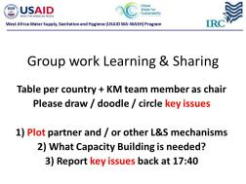

Annex II Capacity Building in Burkina Faso
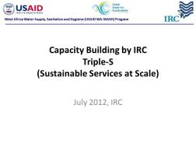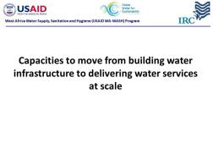
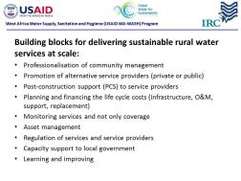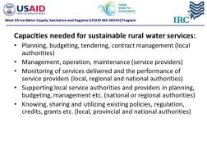
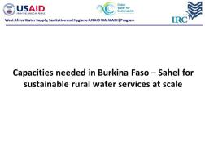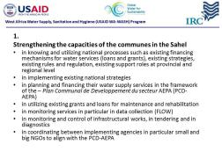
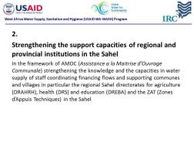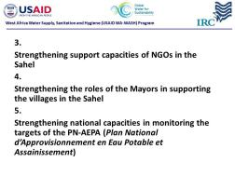
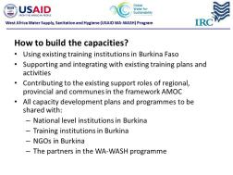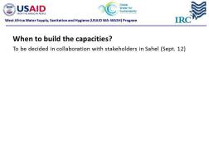
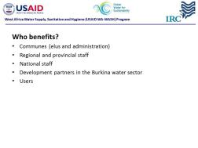

Annex III Capacity Building plans in Burkina Faso
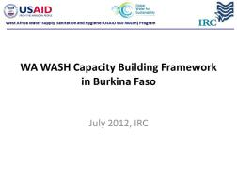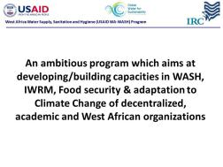
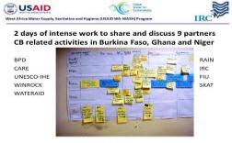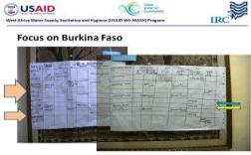
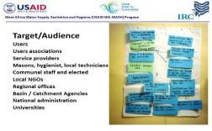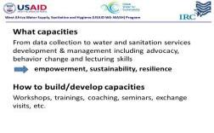
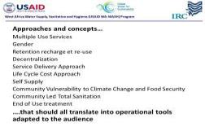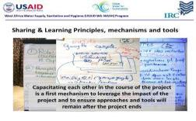
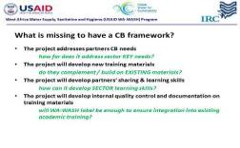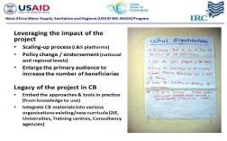

Annex IV Partner meeting linking to capacity building

At the WAWASH partner meeting following the Capacity Building forum partners worked on the partnership and the shared responsibilities, amongst which capacity building.
It became Kristal clear planning and coordination at program and country level was lagging behind. Partly this is due to the delay in contract signing between FIU and partners and partly because country coordinators are missing.
Below are some images illustrating the group work. From top left, an overview off WAWASH sites in Ghana, the needs and two images on the planning. The same order for Mali followed by similar overviews from the regional perspective and Burkina Faso. Blatant was the urge to have a shared calendar
Ghana
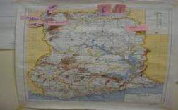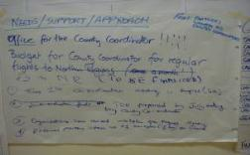
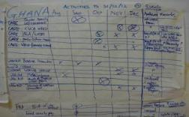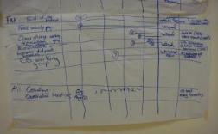
Mali
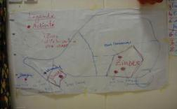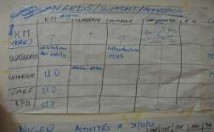
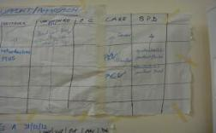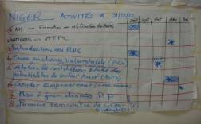
Regional
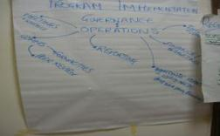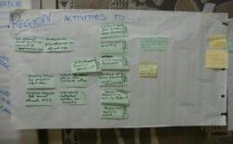
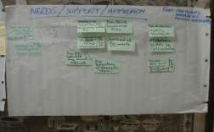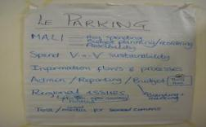
Burkina Faso
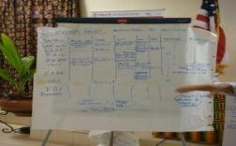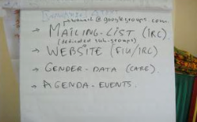

Annex V: Agenda Capacity Building forum
AGENDA Capacity Building Forum, Ouagadougou, 16-18 July 2012
Day 1: 16th July : Internal forum (Participants : WA-WASH partners)
Theme | Time | Session | Presentation | Facilitation | Reporting
Introduction | 13:00 to 13:45 | Introduction+ Summary of programme conferences | FIU | N/A | KM Team
Capacity needs: where do we stand in the 4 countries ? | 13:45 to 14:15 | Country1 :Available capacities at local and country level, capacity gaps at local and country level to meet the MDGs and full coverage, identification of capacity needs | IWA | IRC | KM Team
Capacity needs: where do we stand in the 4 countries ? | 14:15 to 14:45 | Country2 :Available capacities at local and country level, capacity gaps at local and country level to meet the MDGs and full coverage, identification of capacity needs | IWA | IRC | KM Team
Capacity needs: where do we stand in the 4 countries ? | 14:45 to 15:15 | Country3 :Available capacities at local and country level, capacity gaps at local and country level to meet the MDGs and full coverage, identification of capacity needs | IWA | IRC | KM Team
Capacity needs: where do we stand in the 4 countries ? | 15:15 to 15:45 | Break
Capacity needs: where do we stand in the 4 countries ? | 15:45 to 16:15 | Introduction to Regional academic institutions | UNESCO-IHE | IRC | KM Team
Capacity needs: where do we stand in the 4 countries ? | 16:15 to 17:45 | Presentation on knowledge management | IRC | IRC | KM Team
Capacity needs: where do we stand in the 4 countries ? | 16:15 to 17:45 | Presentation of IRC’s assessment results on learning platform capacities | IRC | IRC | KM Team
Capacity needs: where do we stand in the 4 countries ? | 16:15 to 17:45 | Plotting information flows per country | Four 'country-tables' | IRC | IRC | KM Team
 | 17:45 to 18:15 | How to synergize and ensure quality control- first thoughts | All | IRC | KM Team

Day 2: 17th July : Internal forum (Participants : WA-WASH partners)
Theme | Time | Session | Presentation | Facilitation | Reporting
Recap | 8:00 to 8:30 | Wrap up of 1st day | FIU | N/A
Capacity building WA-WASH contributions | 8:30 to 9:30 | Capacity building in Niger (what capacity, how to build it, when by 2015, for who? | BPD, Care, FIU, Rain, Unesco, WaterAid, Winrock | IRC | KM Team
Capacity building WA-WASH contributions | 9:30 to 10:00 | What capacities needs will (not) be addressed by WA-WASH partners?) | All | IRC | KM Team
Capacity building WA-WASH contributions | 10:00 to 10:30 | Break
Capacity building WA-WASH contributions | 10:30 to 11:30 | Capacity building in Burkina Faso(what capacity, how to build it, when by 2015, for who? | BPD, Care, FIU, IRC, Unesco, WaterAid, Winrock, SKAT, RAIN | IRC | KM Team
Capacity building WA-WASH contributions | 11:30 to 12:00 | What capacities needs will (not) be addressed by WA-WASH partners?) | All | IRC | KM Team
Capacity building WA-WASH contributions | 12:00 to 13:30 | Lunch
Capacity building WA-WASH contributions | 13:30 to 14:00 | Capacity building in Ghana (what capacity, how to build it, when by 2015, for who? | BPD, Care, FIU, Unesco, WaterAid, Winrock | IRC | KM Team
Capacity building WA-WASH contributions | 14:00 to 14:30 | What capacities needs will (not) be addressed by WA-WASH partners?) | All | T IRC BD | KM Team
Capacity Building programme in Burkina Faso: how to synergise and quality control ? | 14:30 to 16:00 | Identification of common topics and audiences | TBD | FIU | KM Team
 | 16:00 to 16:30 | Break
 | 16:30 to 17:00 | Peer-review and material sharing processes | IRC | IRC | KM Team
Capacity Building Programme in Burkina Faso: how to involve country CB organisations? | 17:00 to 18:00 | How to involve BF CB organisations to institutionalise CB materials into existing/new curricula | All | IRC | KM Team
 | 18:00 to 18:30 | Wrap up | FIU | N/A

Day 2 IWA side event
Side event 17 July Validation workhsop
Participants: IWA local consultants + invitees
Morning | 8:30 to 12
 | 8:30 to 9 | Welcome and introduction to the validation workshop
 | 9 to 10 | Capacity needs and gaps in the Water Sector
 | 10:30 to 12 | Guided discussion on validating the results
 | 12 to 14 | Lunch
Afternoon | 14 to 18
 | 14 to 15 | Capacity needs and gaps in the Sanitation sector
 | 15 to 15:30 | Start the discussion on validating results
 | 15:30 to 16 | Break
 | 16 to 17 | Continue the discussion
 | 17 to 17: 30 | Recommendations
 | 17:30 to 18 | Discussion on the implementation of the recommendations (are the recommendations applicable? )

Day 3: 18th July, Capacity Building Forum
Participants: WA WASH partners, BF CB organisations, NGOs, CBOs and officials
Time | Session | Presentation | Facilitation | Reporting
8:00 to 8:30 | Welcome of participants |  | N/A
8:30 to 8:45 | Welcome by representant Ministry of Agriculture | Sabne Koanda | FIU
8:45 to 9:30 | Introduction to WA-WASH programme and partners | FIU |  | KM Team
9:30 to 10:30 | Assessment of capacities in BF: methodology, (validated) results and recommandations | IWA (OCI?) | IRC | KM Team
10:30 to 11:00 | Break
11:00 to 12:00 | Presentation of WA WASH CB programme in BF | IRC | IRC | KM Team
12:00 to 13:30 | Lunch
13:30 to 15:30 | Round table discussion : existing curricula on similar topics - | all | KM Team | KM Team
15:30 to 16:00 | Break
16:00 to 17:30 | Presentation on Sustainable Services at Scale: a learning initiative for water services that last | IRC | IRC | KM Team
16:00 | Press conference | Sabne Koanda, USAID/w-AFR, USAID WA-WASH, IRC, IWA | FIU

