

INTERNATIONAL DEVELOPMENT ENTERPRISES

WATSAN PARTNERSHIP PROJECT (WPP)

REPORT

ON

ROPE PUMP

AN ACTION RESEARCH INITIATIVE IN WPP

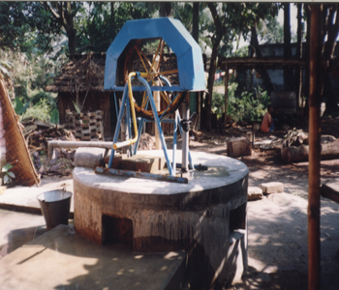



JULY 2002

TABLE OF CONTENTS

A. Introduction 4

B. Research Objectives 4

C. General Description of the Technology 4

D. How Does Pump Work 5

E. Methodology 6

Disinfection of Dug Well Water 7
Disinfection Methodology 7

F. Activities 7

G. Locations of Pumps installed 8

H. Findings 8

H1. Arsenic Test Results 8
H.2. Bacteriological Test Results 9
H.3. Output Capacity 9
H.4. Operation and Maintenance 10
H.5. Usage of Water 10

I. Recommendations 10

Annexes:

Annex-1: Basic Information of Rope Pumps Under Action Research
Annex-2: Checklist for Installation
Annex-3: Rope Pump Monitoring Checklist

A. Introduction:

Since the arsenic issue has arisen in Bangladesh over the several years, many households have reverted to using dug wells as a source of arsenic free drinking water. It is generally accepted that dug wells are arsenic free in the worse cases, may be contaminated with arsenic but bellow the Bangladesh acceptable level.

With the increase use of dug wells as a safe drinking water source, a major problem must be addressed. The sanitary condition, primarily bacteria contamination has caused concern in the health community, as this is a source for transmitting water borne diseases, such as diarrhea, typhoid etc.

The reason for concern for the bacteria contamination is due to the current practice of drawing water. Most dug wells being used for drinking water sources have been fitted with the traditional rope and bucket system. Using the rope and bucket system causes secondary contamination. The temporary solution for this problem is to sanitize the well using chemical treatment. Of course, the secondary contamination will reoccur if no change is made in the water drawing practice.

Over the past 2 to 3 years, the WPP has attempted to solve the sanitation problem of some selected dug wells by fitting 40 wells with sanitary platforms and fitting them with #6 and Deep Set pumps. This solution, although effective, is sometimes not affordable at a household level and the high cost must be shared by the community or subsidized, in order to make it affordable. In addition, 22 wells were sanitized, fitted with a low cost coves and raised outer walls. This solution is more affordable, but continues to use the traditional rope and bucket system that can create a sanitation problem.

B. Research Objectives:

- To adapt a sanitary, socially acceptable technology to dug-wells at a more affordable price while yielding an adequate water discharge.

- To providing a simpler, easier and less labor-intensive technology for drawing water particularly for women and children.

C. General Description of the Technology:

The rope pump is inexpensive, efficient, simple and easy to operate. The heart of the pump is a never-ending ROPE with PISTONS. This rope is raised through a raising main, which passes through a pulley wheel and falls free into the well. Under the water, a guide assures the smooth entrance of the rope and the pistons into the raising main.

Turning the pulley wheel makes the rope move. The pistons give maximum play in the raising main and suction in the water lift. We could say that the whole raising main serves as a long cylinder in which the pistons only move in one direction. When it gets to the top, the pumped water is diverted to the user’s bucket.
The basic characteristics of rope pump are;
- It is simple technology
- Pump is easy to build
- Easy to operate and maintain
- Yields high discharge of water
- Draws water from wells hygienically
- Less labor intensive.

The rope pump is highly efficient and pumps great quantities from 2lps at a depth 5m to 0.3lps at a depth of 40m. The pump is appropriate for an individual domestic water supply from a dug well. It has also been proven that it can be used as a small-scale irrigation device.

D. How Does The Rope Pump Work:
The pulley wheel handle activates a pulley wheel, which is connected to a support structure through the split bearings. The support structure in this case is made of welded iron that can also be made of wood. The heart of the pump is a rope that has pistons every one meters. These pistons can be cut from an old inner tube, turned from wood or extruded from polyethylene or polypropylene. The rope passes over the pulley wheel and enters the protection tube, which serves as a guide to pass through the well slab of concrete. Within the well, the rope lowers freely. At the bottom, under the water level, a guide box assures the fluid entry of the rope with the pistons in the raising main (common PVC, with dia depending on depth). When raised, the rope with the pistons goes inside the raising main and returns by the pulley wheel.

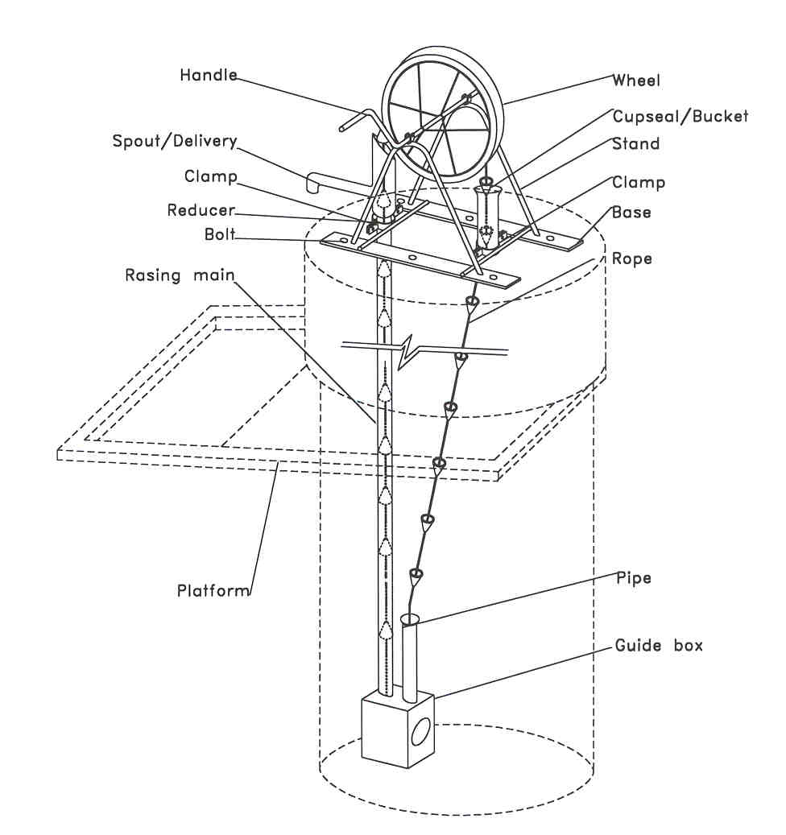

Different Parts of Rope Pump

When the pulley wheel handle is turned, the pulley wheel is activated and friction makes the rope turn. The pistons fit with minimum play into the raising main and each one brings a certain quantity of water up. Once the tube is filled with water, the water column moves uniformly up, pulled by the pistons, with a speed a little less than a rope. It can be said that the entire raising main functions as a vary long cylinder in which the pistons move in just one direction. At the top, the raising main is connected to the discharge spout and through a T-joint the pumped water is diverted to the user’s bucket. The outlet has a large diameter to permit water to be diverted around the pistons and not to overflow from the top.

The weight of the water column exerts force on the pistons, these on the rope, and this transmits by friction the force on the pulley wheel. When finished pumping, the pulley wheel and handle turn back, in the opposite direction of the pumping, with the weight of the water column. At depths greater than ten meters, a blockage system is needed to prevent the pulley wheel handle from hitting the users and the loss of the entire water column. Therefore, the next users should not have to again fill the entire raising main, as long as water has not been lost through the leakage that always exists between the pistons and the raising main.

E. Methodology:

The action research was undertaken in Paba, Bagha, Mohonpur and Nawabgonj (Sadar) Upazillas where most of the tube-wells are arsenic contaminated with high level of concentration. The pumps had been installed on the dug-wells were being used as alternative sources of drinking water in the area. The following selection criteria were followed to start off the research in WPP communities:
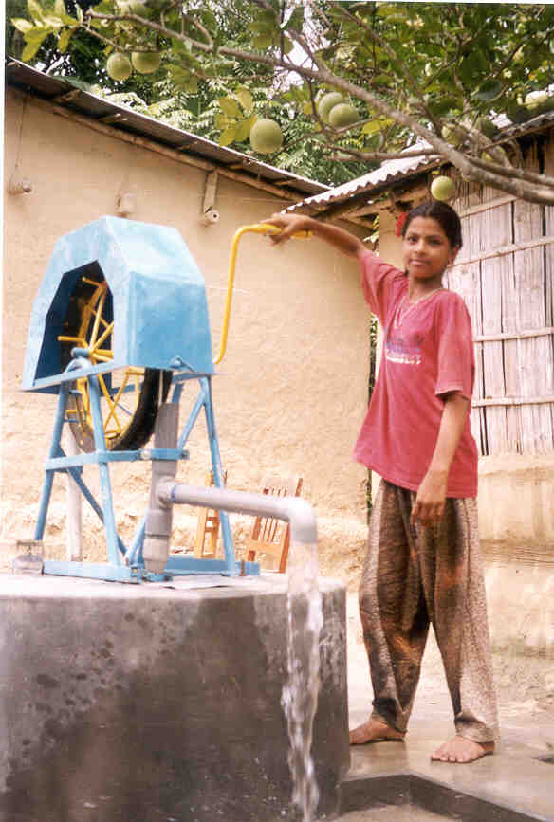

Arsenic contaminated area
- Water scarcity
- VDC areas
- Users demand
- Easy access for community people
- Useable dug-well
- Water is available round the year
- No other options specifically the green tube-well
- 10 to 15 families use the dug well water
- Selected dug well should be located at list 50ft away from toilet

Ring wells should be selected

Users’ opinions were collected through regular monitoring twice a month by using the prescribed checklist and actions were taken in response to user feedback as were necessary.

In addition to the regular monitoring Individual Interview and group discussions were carried out for collection of users’ views on its O&M, usage of water and benefits. 3 FGD (Focused Group Discussion) and 4 Individual Interviews in Paba, Bagmara and Nawabgonj Sadar area were carried out. Twenty-nine users and other family members participated in the Focused Group Discussion sessions.

Bacteriological tests of the wells with rope pumps were done at WPP Laboratory. All the wells were disinfected before the pumps were installed on them. According to WPP experience, dug well water gets infected with bacteria after one to three months of disinfection. As such some of the wells under this research were required to be disinfected after one month and some after two months. Disinfection and its methodology in WPP are stated below.

Disinfections of dug-well water:

Disinfections of dug-well water were carried out with Bleaching Powder of analytical grade (LOBA, India) which contained 32.67% of chlorine. Simple Bleaching Treatment method was applied to all the dug-well water, since it was found that Single Bleaching Treatment is the most effective dug-well disinfecting method over Single and Double Pot Chlorination methods. For disinfections purposes, solution from 200-300 grams of the bleaching powder was added to the dug-well water and the insoluble mass was discarded. The dosage depends on the extent of microbiological pollution of dug-well water, depth of water table, etc.

Disinfections Methodology:

Single Pot Chlorination: A plastic pot containing few small holes at the bottom can be used as a chlorinator. The pot is half filled with pebbles and Domar sand. Bleaching powder and coarse sand is mixed in 1:2 proportions and placed on the Domar sand. The pot is then filled with pebbles and coarse sand up to the neck. The pot is suspended with some strings and lowered into the well with its mouth open.

Double Pot Chlorination: A unit consisting of two cylindrical plastic pots, one inside the other can be used as a chlorinator device. The inner pot with two small holes at the upper level is filled with a mixture of bleaching powder and coarse sand in 1:2 ratios to a level below the holes. The inner pot is placed inside the large pot containing tow holes, one at the top and the other at the bottom. The pot is suspended with some strings and lowered into the well.

Simple Bleaching Treatment: In a small bucket, the desired amount of bleaching powder is mixed well with water to prepare a homogeneous concentrated solution. The bucket containing the solution is then placed into the dug-well water with a rope. The bucket is shaken well so that bleaching powder is mixed with water slowly. After few minutes the remaining solution in the bucket is poured into the water.

It is evident from the results that Single Bleaching Treatment is the most effective dug-well disinfecting method over Single and Double Pot Chlorination methods. Moreover, this method is easier from the point of operation and cost effective, since 0.5 kg of bleaching powder is enough to disinfect dug-well instead of 1.0 kg. Hence, this method has been applied for disinfecting dug-wells.

F. Activities:

Following activities were carried out to implement the research:

- Orientation for IDE-WPP staff
- Orientation for collaborative partners
- Training to PNGO staff
- Practical training for local installers (mistaries)
- Users’ orientation on M&O
- Users’ and sites selection
- Collection of shared cost
- Arsenic test of dug-well water by E-Merck kit
- Bacteriological tests after installation of the pumps in WPP laboratory.
- Disinfecting the dug-wells
- Monitoring (collection of users feedback) twice in a month
- Interview & FGD with users

G. Locations of the Pumps Installed:

A total of 13 rope pumps were installed in different areas under WPP during the period from September 2001 to February 2002. Three were installed in Paba, four in Bagha one in Mohonpur and five in Nawabgonj (Sadar) Upazilla. The details are given in Table-1:

Table-1
Sl.. | PNGO | Upazilla | District | No. of pump installed
1 | MSP | Paba | Rajshahi | 2
2 | KSS | Bagha | Rajshahi | 4
3 | SDP | Mohonpur | Rajshahi | 1
4 | SNKS | Paba | Rajshahi | 1
5 | PROYAS | Nawabgonj (Sadar) | Chapai Nawabgonj | 3
6 | Trinomool | Nawabgonj (Sadar) | Chapai Nawabgonj | 2
Total |  |  |  | 13

H. Findings:

The findings of the research include arsenic test results, bacteriological test results,
operation & maintenance, output capacity of rope pump and usage of water.

H.1. Arsenic Test Results:
Arsenic tests of the dug-well water were carried out by E-Merck field test kit after installation of Rope pump. All dug-well water found arsenic free. Table-2 contains the results.

Table-2

Pump ID No. | PNGO | Upazilla | Date of  Installation | Arsenic Test Results in mg/L
 |  |  |  | Sept.01 | Oct.01 | Nov.01 | Dec.01 | Jan.02 | Feb.02 | Mar.02
Rope-1 | MSP | Paba | 24.09.01 | 0.00 | 0.00 | 0.00 | 0.00 | 0.00 | 0.00 | 0.00
Rope-2 | MSP | Paba | 24.09.01 | 0.00 | 0.00 | 0.00 | 0.00 | 0.00 | 0.00 | 0.00
Rope-3 | SNKS | Bagha | 25.09.01 | 0.00 | 0.00 | 0.00 | 0.00 | 0.00 | 0.00 | 0.00
Rope-4 | SNKS | Bagha | 26.09.01 | 0.00 | 0.00 | 0.00 | 0.00 | 0.00 | 0.00 | 0.00
Rope-5 | SNKS | Bagha | 27.09.01 | 0.00 | 0.00 | 0.00 | 0.00 | 0.00 | 0.00 | 0.00
Rope-6 | SNKS | Bagha | 03.10.01 | - | 0.00 | 0.00 | 0.00 | 0.00 | 0.00 | 0.00
Rope-7 | Trinomool | Nawabgonj | 17.10.01 | - | 0.00 | 0.00 | 0.00 | 0.00 | 0.00 | 0.00
Rope-8 | Trinomool | Nawabgonj | 22.10.01 | - | 0.00 | 0.00 | 0.00 | 0.00 | 0.00 | 0.00
Rope-9 | PROYAS | Nawabgonj | 05.11.01 | - | - | 0.00 | 0.00 | 0.00 | 0.00 | 0.00
Rope-10 | SDP | Mohonpur | 06.11.01 | - | - | 0.00 | 0.00 | 0.00 | 0.00 | 0.00
Rope-11 | PROYAS | Nawabgonj | 08.11.01 | - | - | 0.00 | 0.00 | 0.00 | 0.00 | 0.00
Rope-12 | PROYAS | Nawabgonj | 16.01.02 | - | - | - | - | 0.00 | 0.00 | 0.00
Rope-13 | KSS | Paba | 10.02.02 | - | - | - | - | - | 0.00 | 0.00

H.2. Bacteriological Test Results:
Bacteriological tests of the wells were carried out at WPP Lab routinely. Test results are shown in the Table- 3. It also contains the dates of disinfections of the wells. All the wells were disinfected once before the installation of rope pumps. For the second time, disinfections were carried out in the wells when bacteriological test results showed that the water is containing high level of CFU. Due to lack of necessary reagents, testes could not be done in the months of November and December 2001.

Table-3

Pump ID No. | PNGO | Upazilla | 1st Disinfection date | Date of  Installation | 2nd Disinfection date | Bacteriological Tests results  CFU/100ml of water
 |  |  |  |  |  | Oct .01 | Jan.02 | Feb.02 | Mar.02
Rope-1 | MSP | Paba | 20.9.01 | 24.09.01 | 5.12.01 | 28 | 12 | 6 | 8
Rope-2 | MSP | Paba | 20.9.01 | 24.09.01 | 6.11.01 | 112 | 04 | 22 | Nil
Rope-3 | SNKS | Bagha | 16.9.01 | 25.09.01 | 6.11.01 | 92 | Nil | 8 | 10
Rope-4 | SNKS | Bagha | 17.9.01 | 26.09.01 | 6.12.01 | >200 | 20 | 60 | 20
Rope-5 | SNKS | Bagha | 18.9.01 | 27.09.01 | 5.12.01 | >200 | >200 | 6 | 4
Rope-6 | SNKS | Bagha | 20.9.01 | 03.10.01 | 6.11.01 | 150 | 2 | 4 | Nil
Rope-7 | Trinomool | Nawabgonj | 3.10.01 | 17.10.01 | 20.11.01 | >200 | 56 | 50 | 14
Rope-8 | Trinomool | Nawabgonj | 19.10.01 | 22.10.01 | 20.12.01 | >200 | >200 | 12 | >200
Rope-9 | PROYAS | Nawabgonj | 1.10.01 | 05.11.01 | 5.8.01 | - | 90 | 120 | 200
Rope-10 | SDP | Mohonpur | 4.11.01 | 06.11.01 | 20.5.02 | - | 176 | 8 | Nil
Rope-11 | PROYAS | Nawabgonj | 5.11.01 | 08.11.01 | 6.5.02 | - | 8 | 4 | 12
Rope-12 | PROYAS | Nawabgonj | 13.1.01 | 16.01.02 | 7.6.02 | - | 120 | >200 | 200
Rope-13 | KSS | Paba | 29.1.02 | 10.02.02 | 10.5.02 | - | - | 54 | Nil

It is to be noted here that some of the dug-wells with the Rope Pumps were either excavated or renovated under the “Post Flood Rehabilitation Program” and as a part of exploring mitigation options under WPP Arsenic Program.

H.3. Output Capacity:
The output capacity of Rope pump is found to be higher in comparison to other suction pump those are functioning with dug-wells. The output capacity of each pump under action research was monitored regularly. The capacity ranges from 23-32 L/minute as shown in Table-4.

Table-4
Pump ID No. | 1 | 2 | 3 | 4 | 5 | 6 | 7 | 8 | 9 | 10 | 11 | 12 | 13
Output (Liters/minute) | 30 | 28 | 24 | 23 | 24 | 23 | 26 | 36 | 32 | 32 | 36 | 32 | 24

H.4. Operation and Maintenance:
It has come out from the routine monitoring findings that the people are gradually becoming interested in having rope pumps installed on their dug-wells. Because:
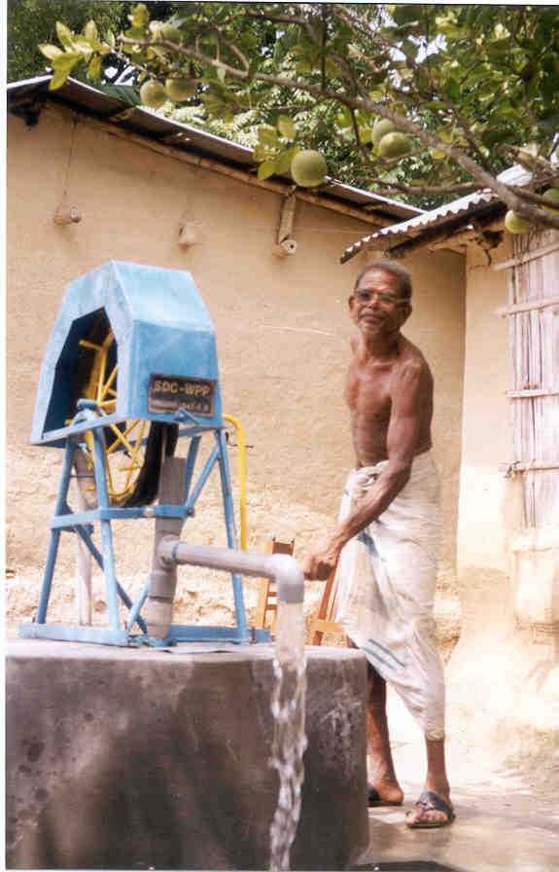
- Users can get arsenic free water through it
- It delivers water hygienically
- Well water is protected from contamination through opening
- It is affordable
- Easy to operate
- Women, children and the elderly like it more as it is a simple and less labor-intensive technology.

H.5. Usage of water:
The water of dug-wells with Rope pump is used in all household purposes that include drinking, cooking, bathing, washing and gardening. Distributions of water are shown in the Table-5.

Table-5
Sl. | Pump ID | 1 | 2 | 3 | 4 | 5 | 6 | 7 | 8 | 9 | 10 | 11 | 12 | 13
Sl. | Purposes
 |  | % | % | % | % | % | % | % | % | % | % | % | % | %
1 | Cooking | 50 | 40 | 20 | 20 | 20 | 25 | 40 | 50 | 40 | 30 | 20 | 20 | 40
2 | Drinking | 20 | 2 | 20 | 5 | 10 | 25 | - | 10 | 15 | 50 | 20 | 15 | 40
3 | Washing | 10 | 20 | 20 | 20 | 20 | 10 | 30 | 20 | 15 | 10 | 20 | 20 | 10
4 | Bathing | 15 | 35 | 10 | 20 | 20 | 10 | 20 | 20 | 25 | 5 | 30 | 20 | 10
5 | Others | 05 | 03 | 30 | 35 | 30 | 30 | 10 | - | 05 | 5 | 10 | 25 | -
 | Total | 100 | 100 | 100 | 100 | 100 | 100 | 100 | 100 | 100 | 100 | 100 | 100 | 100

I. Recommendations:

According to the analysis under Action Research on dug well in WPP revealed that 96.8% of renovated and 87.5% of excavated covered dug well water contained arsenic concentration below Bangladesh standard. Disinfecting method of dug well water in WPP found to be effective that users can do by themselves to keep their dug well water free from bacteria. Users’ opinions showed that water lifting is easy with rope pump on dug well i.e. less labor intensive, water can be drawn in hygienic condition and it yields higher output. Therefore, it is recommended that rope pump can be promoted in WPP particularly in the arsenic affected area by ensuring education on operation and maintenance and hygiene education.

