Sustainable Drinking Water Services at Scale: Everyone Forever
New Delhi, March 2013
Summary Report
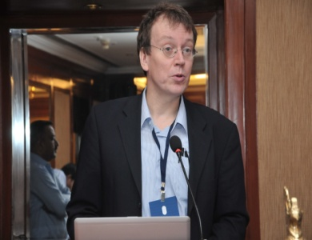
On the 13th of March 2013, a roundtable meeting—on the theme of sustainable drinking water services— was jointly organised by IRC International Water and Sanitation Centre (IRC), the Centre of Excellence for Change (CEC) and All India Disaster Mitigation Institute (AIDMI). Attended by 41 key sector stakeholders from the Government of India, State Governments, the World Bank, UNICEF, WSP-SA, the EU, WaterAid, Water for People, Centre for Economics and Social Studies (CESS), Centre for Science and Environment (CSE), other NGOs and the private sector, the activity took place at the Habitat Centre in New Delhi.
Joep Verhagen, IRC Programme Manager of South Asia, welcomed the participants. In his welcome remarks, he discussed the purpose of the workshop and some challenges faced currently by the water sector in India. In order to address these challenges, Mr Verhagen stressed the need for collaboration across Governments, NGOs, funding agencies and research organisations in identifying possible solutions. He explained, IRC can play a role in bridging the gap between “policy and practice”, working in close collaboration with sector players in India.
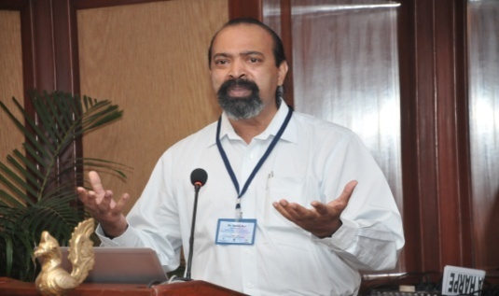
The presentation “Global learning in sustainable drinking water services at scale – everyone forever” kick-started the meeting. In place of Jean de la Harpe, Dr AJ James presented in this session. Chaired by Mr Sudhir Prasad, Additional Chief Secretary of the Government of Jharkhand, Dr James’ presentation highlighted some key issues behind sustaining WASH service delivery. Focusing on the negative impacts of poor financing for WASH, Dr James stressed that poor financing combined with the lack of financial and technical post construction support have both resulted in a deterioration of services. His presentation emphasised the need to provide continuous support to communities based on 5 Ms: mentoring support, management support (budgeting, financial and operational planning, financial management, asset management, human resource issues), monitoring support, major maintenance support and mobilisation (e.g., on-going training activities). He asserted the need to take organised steps for: (1) developing a clear water and sanitation policy and legislation, (2) developing financing strategies, (3) defining targets based on WASH services for everyone forever, (4) implementing sector collaboration, (5) implementing effective decentralisation processes, (6) introducing appropriate context-specific institutional arrangements, and (7) providing support at the “right” time. Mr Prasad added that operation and maintenance continues to be a major issue, and stressed that the community/ Panchayat Raj institutions need financial support, for them to take overall responsibility. Mr Prasad explained that waiting for capacities to strengthen within the Panchayats may be too late. He explained that a simultaneous process of decentralisation and capacity building need to be undertaken to ensure the sustainability of WASH services.
Pankaj Jain, Secretary of the Drinking water supply and sanitation of the Government of India, officially inaugurated the workshop in the presence of T.M. Vijaya Bhaskar, Joint Secretary. In his opening remarks Mr Jain said that 8-10 states in India are suffering from drought conditions due to scarce rainfall—yet another issue that needs to be considered in providing sustainable drinking water.
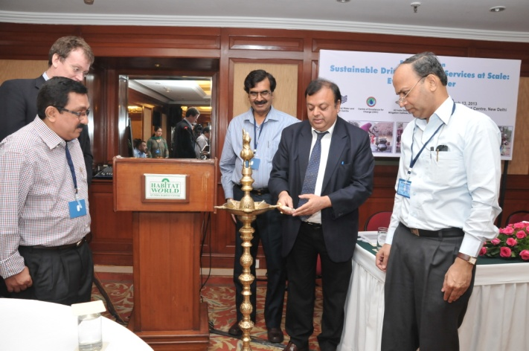
According to Mr Jain, 80% of all drinking water schemes are ground-water based. As hardly any recharge of ground water is taking place, he explained that the Department had no other option but to shift to surface water sources. Unfortunately, ensuring the sustainability of surface water is also a challenge, said Mr Jain, owing to the effects of climate change, the closure of river basins, and varied snow melting conditions. He also stressed that the continued provision of infrastructure to reach the Department’s new target of 55% households with piped water connections by 2017, and everyone by 2025, is insufficient in as long as asset maintenance, institutional frameworks and technical and environmental solutions are weak, lacking and unsustainable. Ensuring potable water quality is also problematic owing to contaminated sources from treatment plants and sewerage systems. Mr Jain insisted on the need to revitalise the panchayats by building capacities, encouraging cost recovery and asset maintenance, and ensuring ring-fenced financing for post construction support. Finally he concluded that the States have enough money to tackle such issues provided that they manage resources effectively with the appropriate technological solutions and human resources.
Vibhu Nair, Founder of CEC, made a (virtual) presentation on change management based on the transformation of Tamil Nadu’s Water Supply and Drainage Board. In his presentation, Mr Nair focused on the need to merge the aspects of purpose, people, process and praxis for any change management process to be successful. Change management, he explained, is built upon value systems of individual staff members. The findings of his study revealed the interplay between the individual value system and (reinforced) leadership in determining the (positive) outcome of a change management process. He also highlighted the significance of conducting trainings to empower staff in addressing issues of political interferences, corruption, conflict management, etc. In the discussions that followed, Mr Sudhir Prasad requested CEC to open a small CEC chapter in Jharkand. Other participants sought clarification on the scale of change management processes and the costs of undertaking such an initiative.
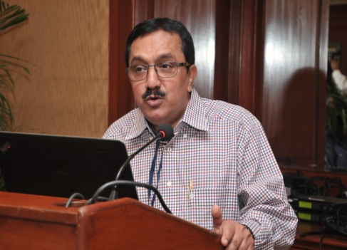
The afternoon session was chaired by Dr AJ James. Dr Kurian Baby, IRC India Country Director, discussed the issue of water security in India. According to Dr Baby, most parts of India are now facing physical water scarcity, with a declining per capita availability of water. Mere access to physical infrastructure is not ‘service delivery’, explained Dr Baby; 30-35% schemes are dysfunctional, and another 30% functioning sub-optimally. Source unsustainability (quantity + quality) is the major challenge, he stressed, and investment trajectory—which is predominantly hardware driven—is limited to financing storage, conveyance, and distribution. In order to change the bleak prospects of water security, Dr Baby called upon the participants of the roundtable discussion to take a “U-turn in addressing the time bomb that is water (source) security”. For sustainable services to be realised at scale, the convergence of actions and public investment towards ensuring water (source) security at decentralised governance levels and through effective regulation is a necessity. To this end, developing an accurate database on functionality and water quality that is monitored at all levels was emphasised as one way of achieving integrated planning.
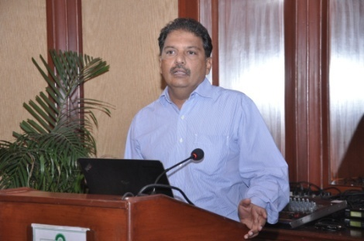
Prof Ratna Reddy presented on a life-cycle costs approach (LCCA) as a means to achieving sustainable service delivery. Based on the findings of a multi-country action research conducted by IRC with partners, actual public sector expenditure on rural drinking water services was found to be much higher than norms used for budget allocations. Prof Reddy exclaimed that infrastructure takes a “lion’s share”, neglecting other important components for sustainable WASH services; e.g., capital maintenance (CapManEx) and source protection, etc. In the absence of budget allocation towards CapManEx, the study revealed that it was practice for budget adjustments to be made in Operational and maintenance Expenditure (OpEx) to meet exigencies. As a result both capital maintenance and operational maintenance suffer, and an increase in the share capital expenditure is observed. Though various components of LCCA are not new, Prof Reddy reported that life-cycle costs are often not considered in budgeting for WASH. During the open forum, the following practical suggestions were gathered: (1) ensure that budgeting of life-cycle costs components is based on real expenditure using the indicative allocations captured in the new drinking water guidelines (NRDWP) for instance; and (2) reorient budgeting practice, allocating funds for CapManEx and ring fencing allocation to OpEx and other components. Participants expressed that the method of using transactional costs and bench marks for service levels vs actual investment is useful for planning and implementing, and requested for more information on where materials may be accessed.
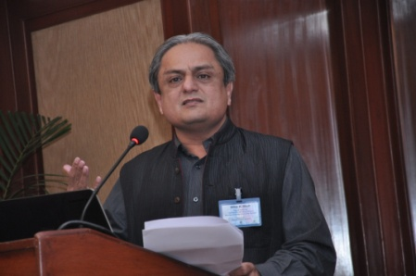
Entitled “Sustainability of Drinking Water Services and Disasters: Some Reflections”, AIDMI’s Mihir Bhatt’s presentation touched upon the absence of disaster mitigation strategies that take into account water access and delivery. According to Mr Bhatt, many State disaster plans do not mention drinking water in planning, and there is a lack of data articulating the interplay between disasters and drinking water. As a step forward, he suggested to include a disaster preparedness component in planning for/ assessing water service safety audit, water service DRMs, and water service retrofitting. He also mentioned that disaster preparedness is crucial in ensuring the sustainability of water and sanitation facilities, as in case of Gujarat. In the exchanges that took place following his presentation, Dr AJ James pointed out that some information on the interplay between disasters and drinking water already exists as he himself was involved in conducting some studies on the topic.
Defining the relevance and value-add of an IRC country programme in India

Armugum Kalimuttu, Water For People: focus on IRCs strengths and delimit work only on specific areas/ themes rather than tackling the country’s WASH sector as a whole. Analyse critically all elements before implementation
Mr.Bhist, LBSNAA: develop modules for IAS officers “We have done one exercise for climate change and I am expecting the same from IRC to provide inputs”
Mihir Bhatt, AIDMI: include risks and disaster mitigation in planning for sustainable WASH services
Sampath, Water for people: focus on disseminating knowledge from sector players; act like a think tank that gathers and shares information
Dr AJ James: do not do everything, set up learning alliance, establishing a platform for knowledge sharing; act as coordinators of change for small NGOs, replicating successful models and taking these to the sector; and set in place effective monitoring systems to map out technological breakthroughs
Vaidyanathan, CEC: create and facilitate a platform that brings all States secretaries and Ministries together to undertake change management initiatives with support from CEC; link up with CEC, which has an organised youth congress and is in the midst of developing research proposals; support small-scale initiatives: some NGOs are already doing good work, facilitate and promote cross learning; facilitate capacity building and conduct action research
Murugan Gangadharan, GOI: “IRCs core strength is sanitation hence the need to work on this. Solid and liquid waste disposal is a big problem and there continues to be a dearth in both technical and community management solutions”.
Mandiratta: enhance rapport with Government; conduct evidence-based research leading to influencing policy directions; documenting the success for sharing especially the coverage
Ramachandrudu, WASSAN: knowledge management and capacity building
Dr Alivelu: action research and capacity building
Nidhi Water people: think globally and act locally
Nagarajan Kuppuswamy, CEC: focus on location-specific and innovative technologies and processes in WASH; “There is a proposal for establishing an India water organisation in partnership with the DDWS, MOWS, RD civil societies IRC should partner and lead this water organisation”.

Using Go To Meeting online meeting software
More information on WASHCost’s research is available on the WASHCost website: http://www.washcost.info/; a brief information sheet on cost benchmarks may be viewed from here: http://www.washcost.info/page/2386

